**ITIS 4250/5250**

**Semester Project**

**Pooja Haridasyam**

**Overview:**

Detective Jessica Fletcher, who was 96 years old, passed away. On November 18th, 2022, Dr. Quincy requested to take on her final case and asked for a desktop computer to be provided. Detective Fletcher had obtained a search warrant from the North Carolina District Court and had seized a computer belonging to a person named Gene Poole, who was a previous offender involved in the production and distribution of drugs. My task was to analyze the forensic image of Gene Poole's computer, which was suspected to contain anti-forensic technology.

**Forensic Acquisition and Exam Preparation:**

Use AccessDataFTKImager to load the image named Gene2022.E01 and confirm its validity.

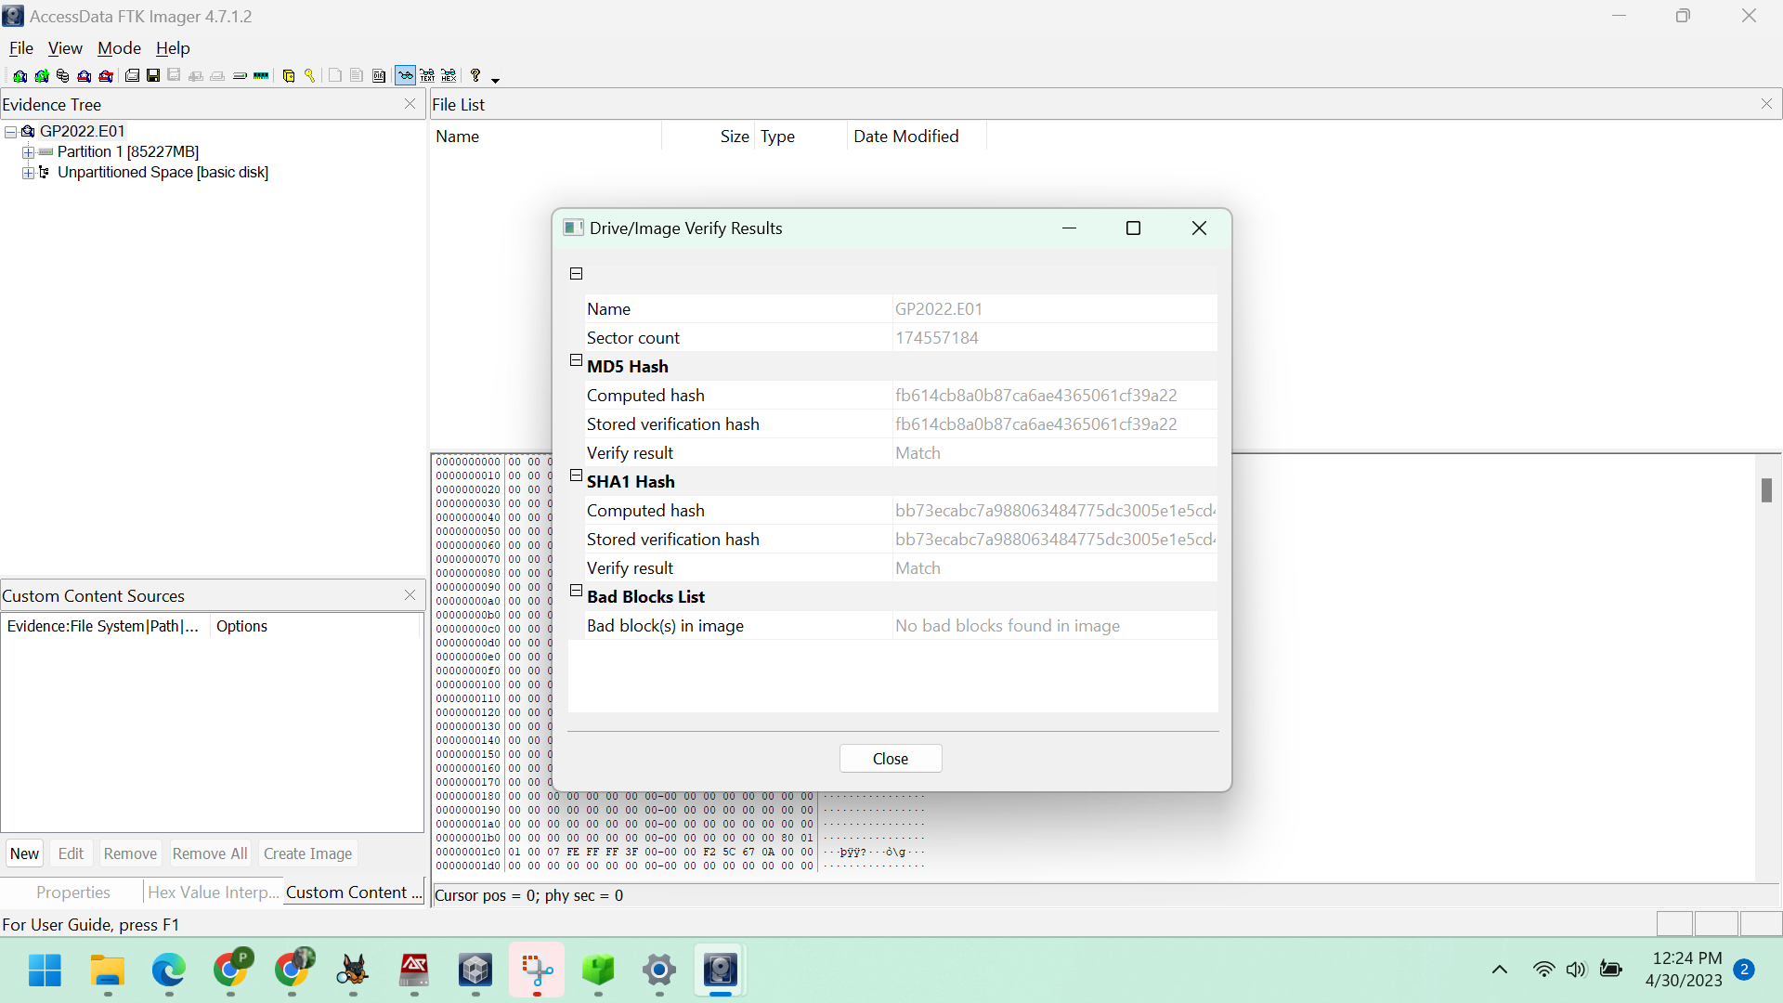

Figure: Verified Hash values

Verified Hash value: fb614cb8a0b87ca6ae4365061cf39a22

**Attach the image file to Arsenal Image Mounter v3.9.228:**

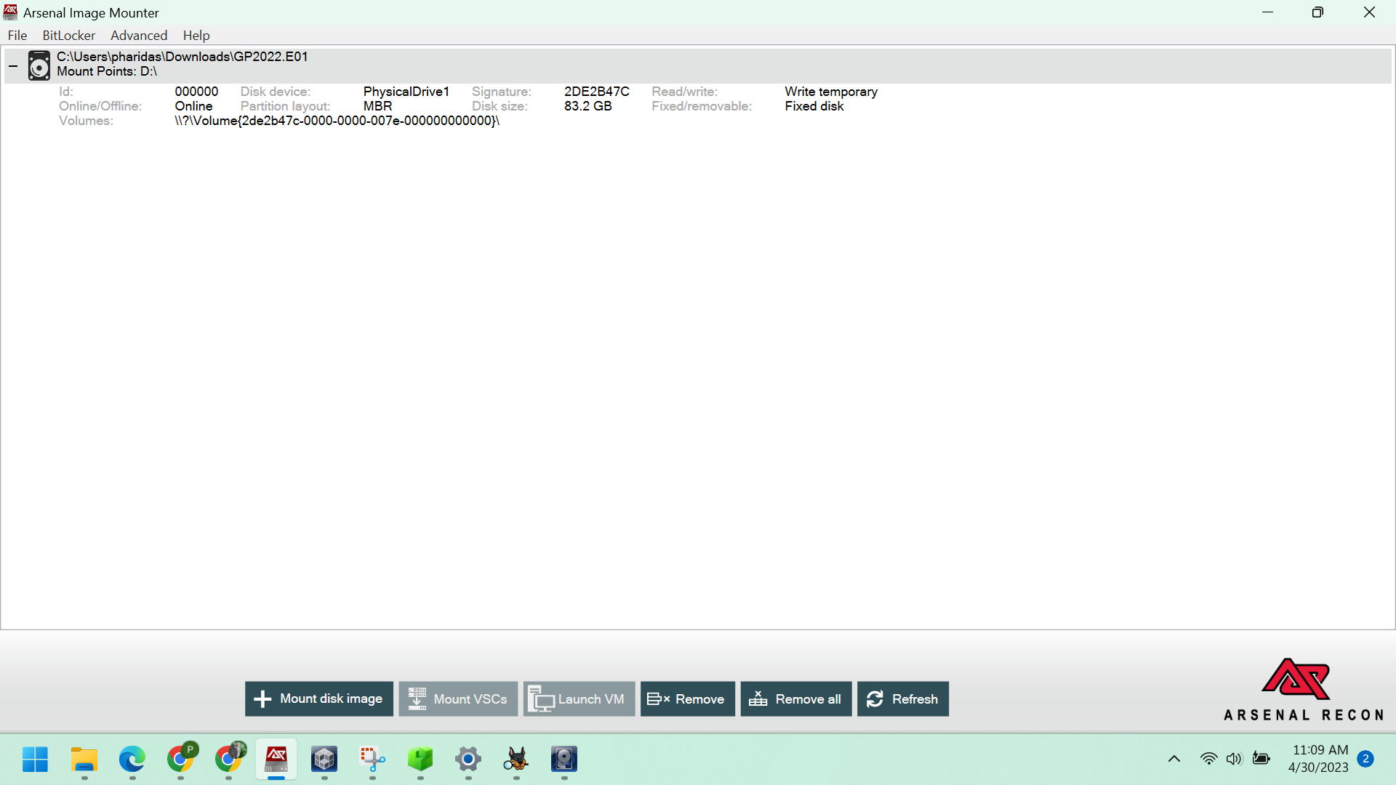

**Software used for examination of the task:**

1. AccessData FTK Imager version 4.7.1.2 for 64-bit systems
2. Autopsy version 4.20.0 for 64-bit systems
3. A Dell Latitude 7400 laptop running the Windows 1 operating system, with 8GB of RAM
4. Win Prefetch Viewer v1.37 for 64-bit systems
5. Arsenal Image Mounter version 3.9.228
6. Access Data Registry Viewer version 2.0.0

**Forensic Analysis:**

Launch Autopsy, then generate a new case and incorporate the Gene2022.E01 file as the data source.

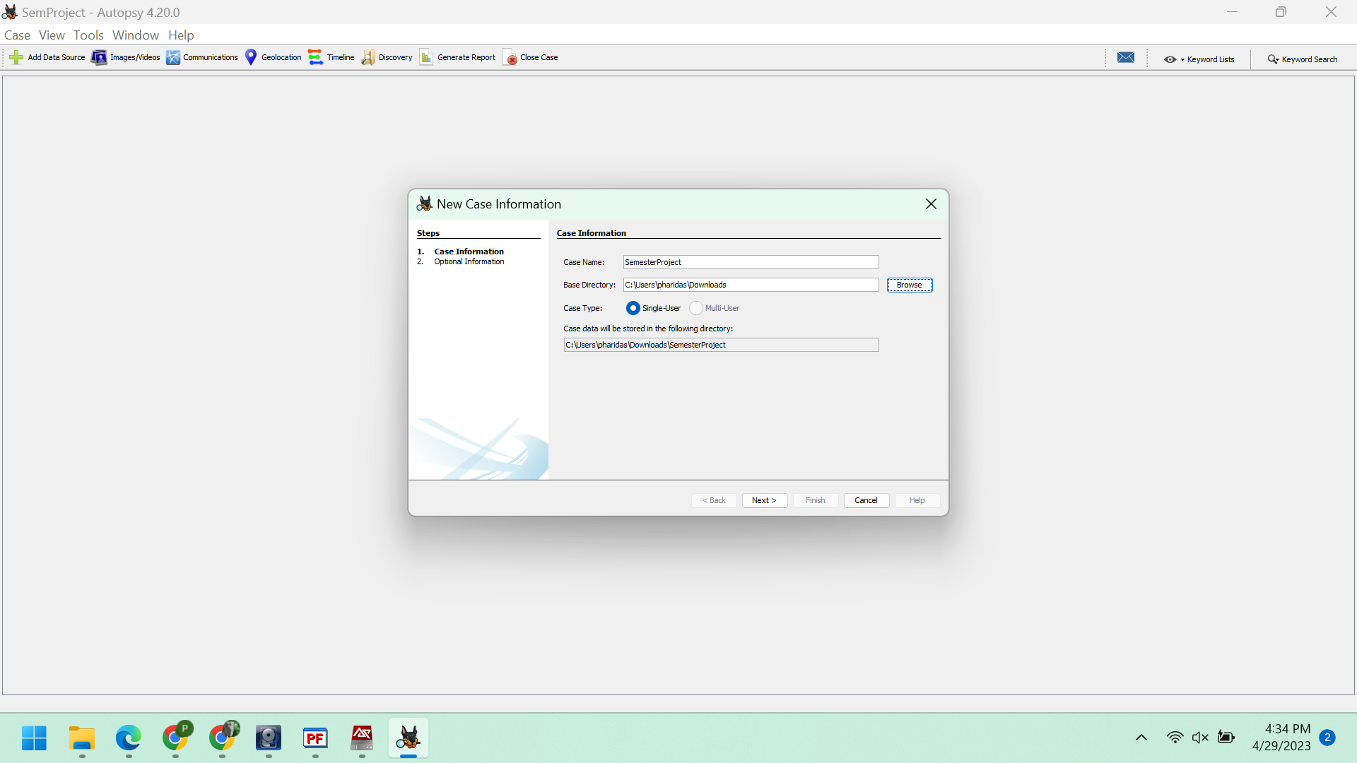

*Figure: Case information*

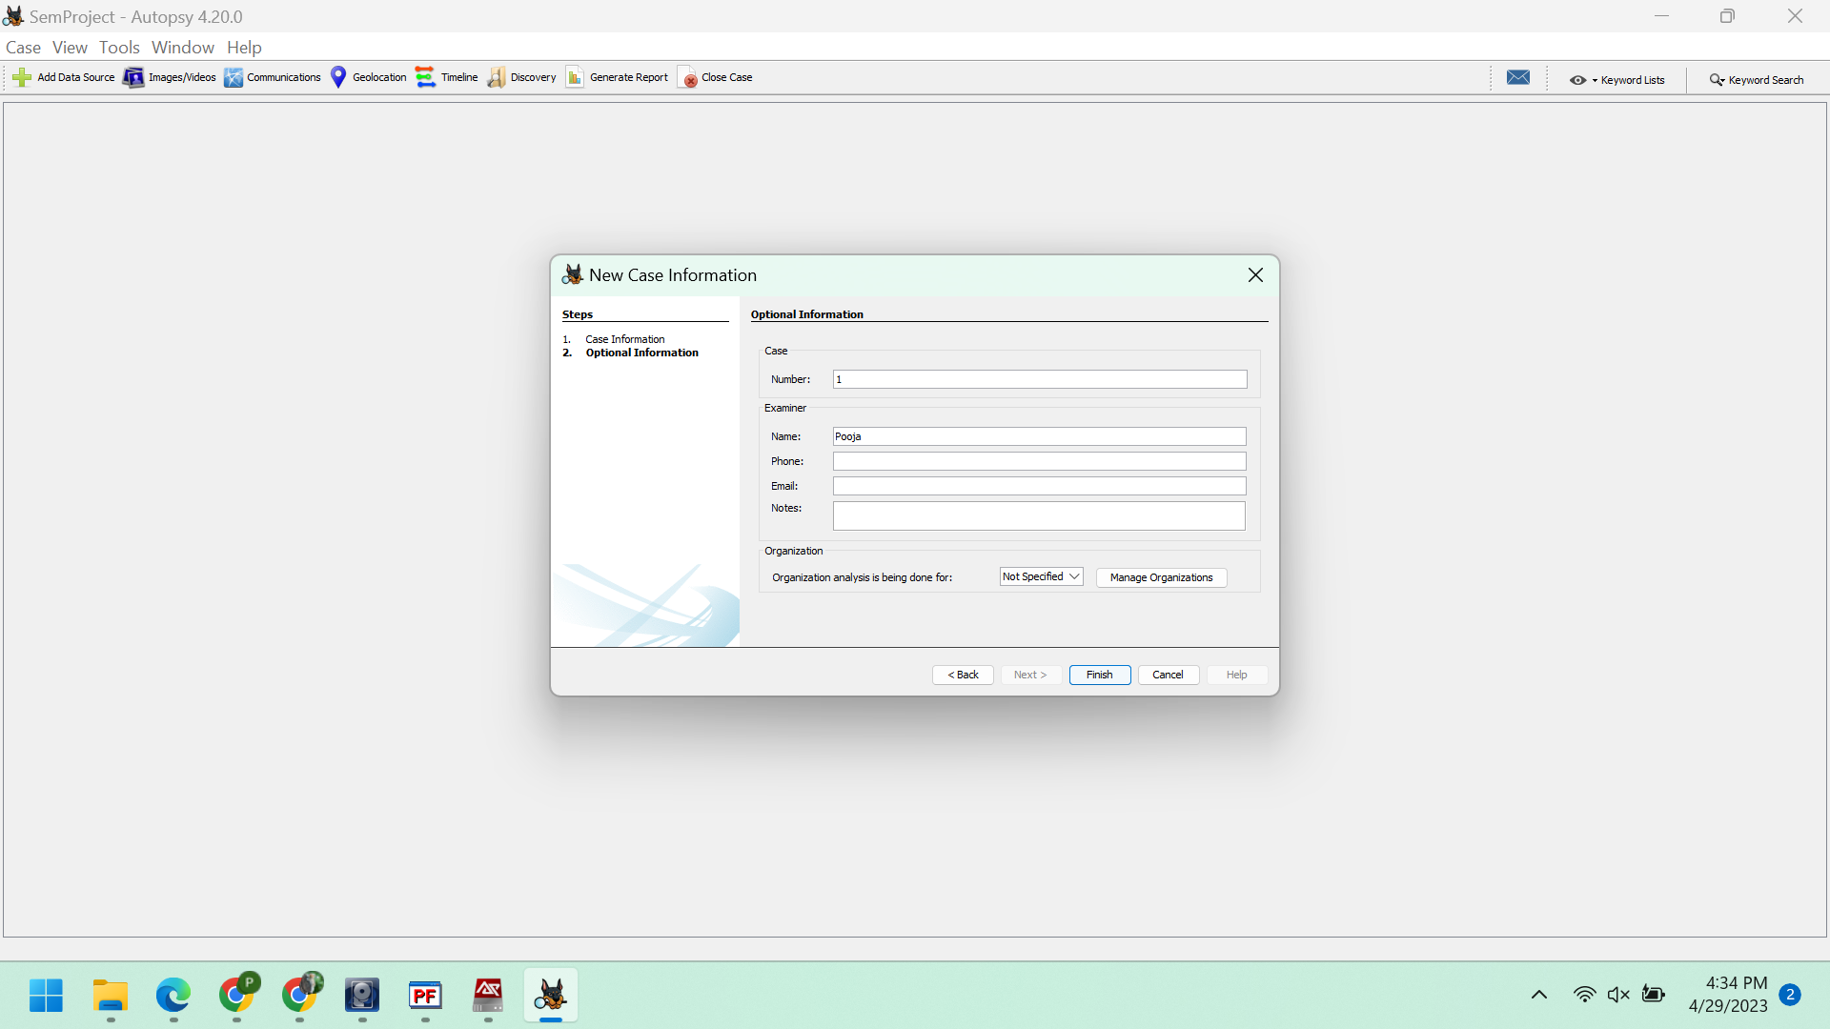

*Figure: Optional information*

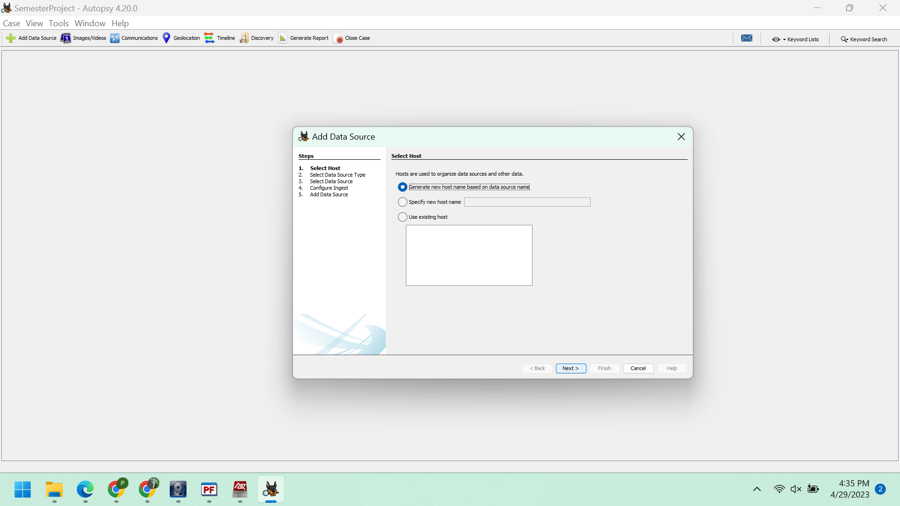

*Figure: Adding the Data Sources*

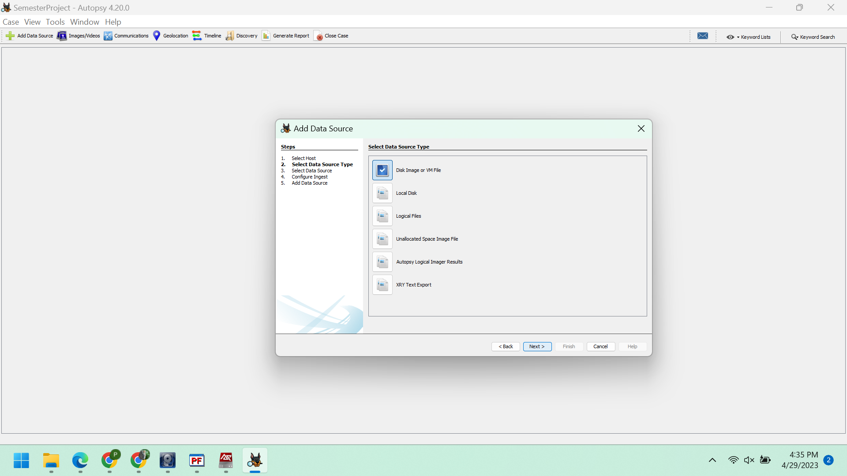

*Figure: Selecting datasource type*

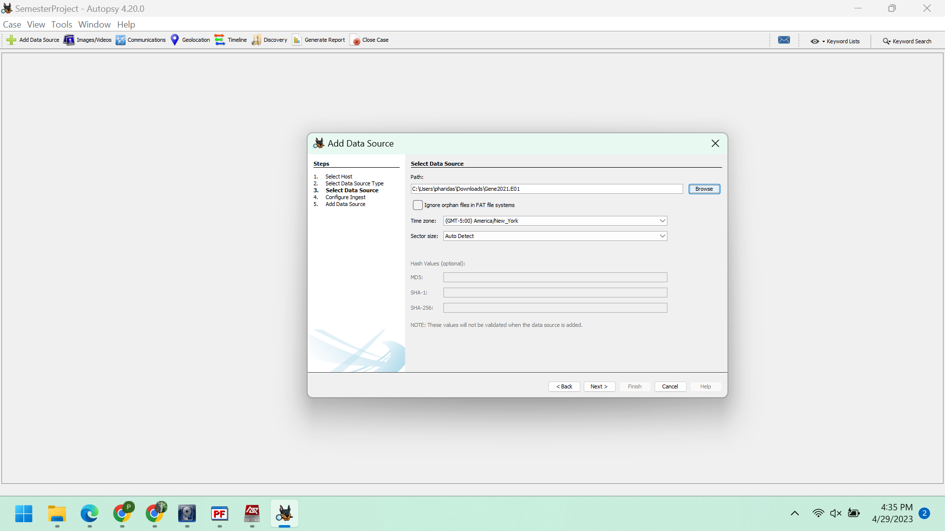

*Figure: Selecting data source*

Choose all the ingest modules and then click on the "Next" button.

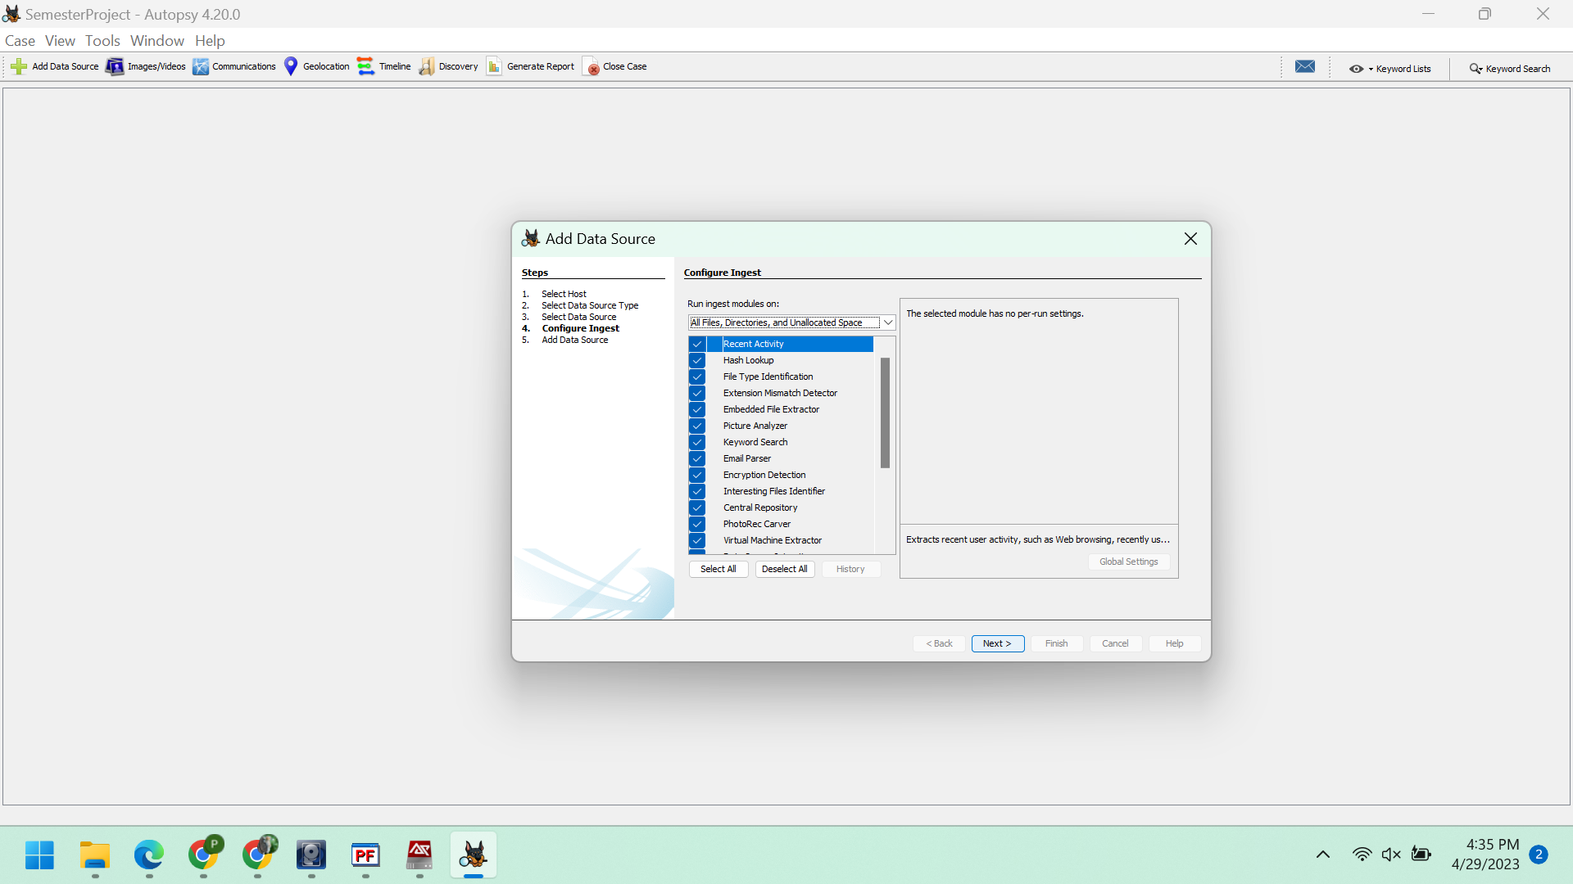

*Figure: Selecting the ingest modules*

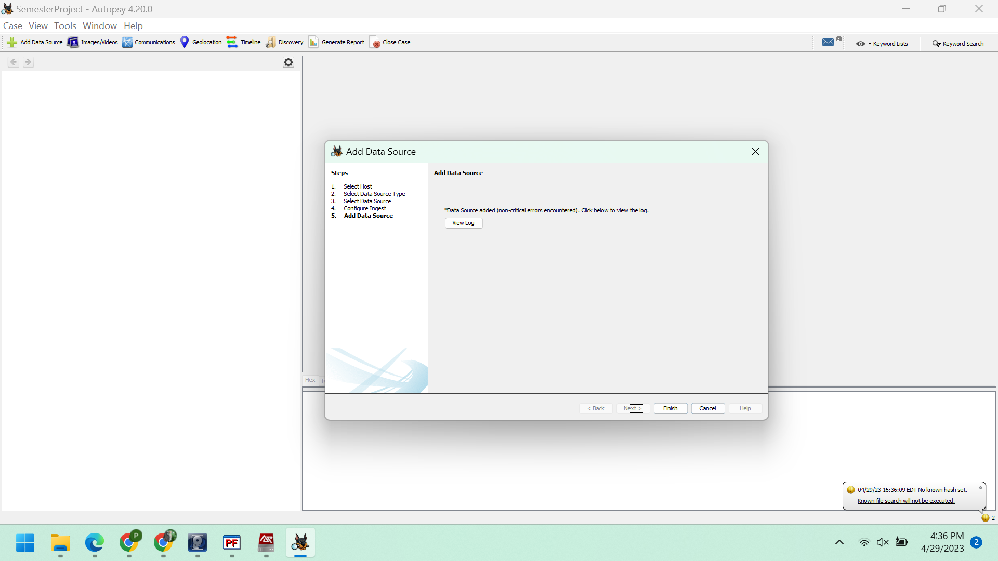

*Figure: Adding data source*

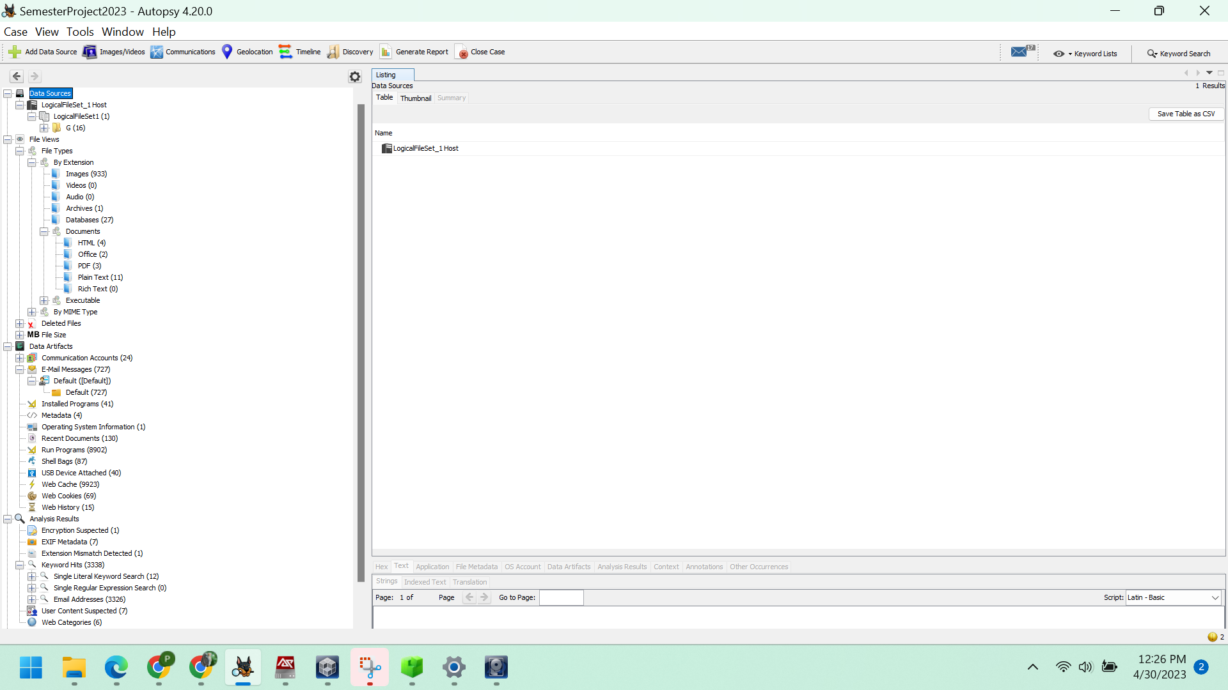

*Figure: Data sources*

By utilizing the previously mentioned tools, Autopsy and Registry Explorer, we can discover solutions to the following inquiries and carry out the analysis:

1. Gene denies the computer is his. What was the name of the computer?

The information can be located under Data Artifacts -> Operating System Information -> SYSTEM -> Name.

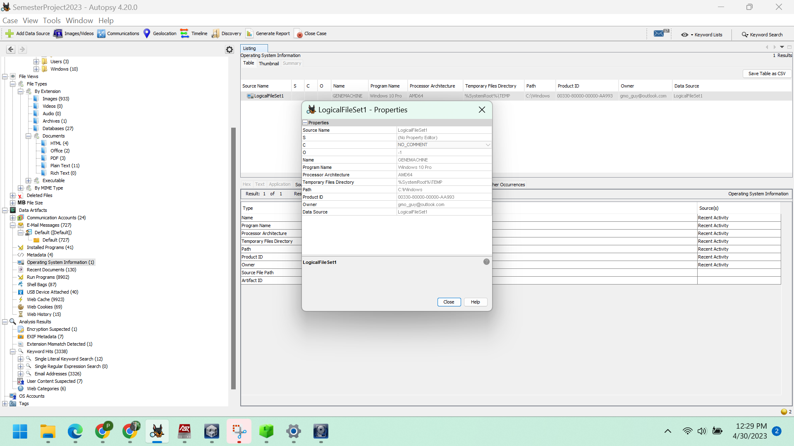

*Figure: Name of the computer*

It is evident that the name of the computer is GENEMACHINE.

2. Rett Harring admitted during an interview with Bladen County Sheriff’s Department Detectives that he picked up a pill press on a trip for Gene down to Dublin, NC, but denied delivering several crates of genetically modified peanuts to Houston’s Peanuts in Dublin. The diligent workers as Houston’s thought something was weird about the delivery and called the Sheriff’s Department. Is there any evidence Gene knew Rett would travel to Dublin from his home in Salemburg, NC?

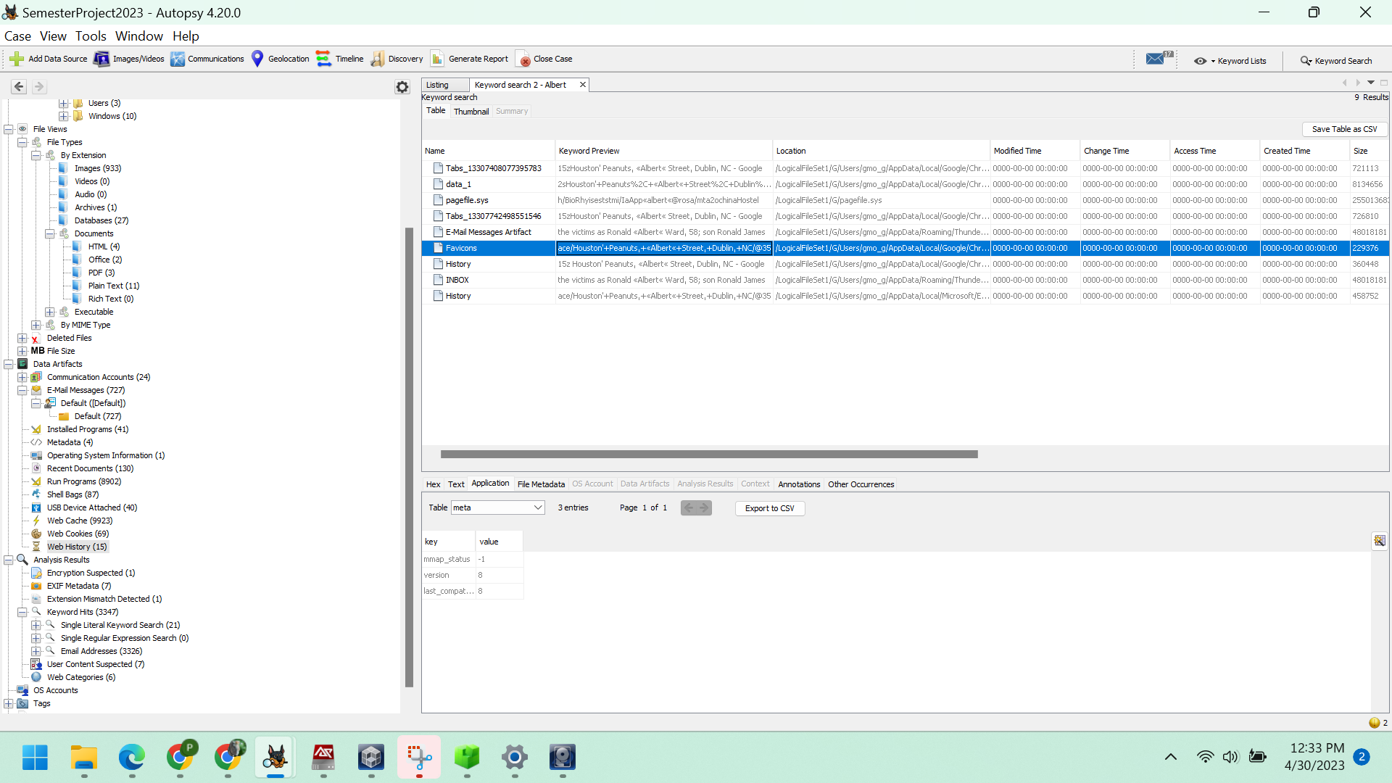

*Figure: Details about the journey between Salemburg, NC and Houston Peanuts.*

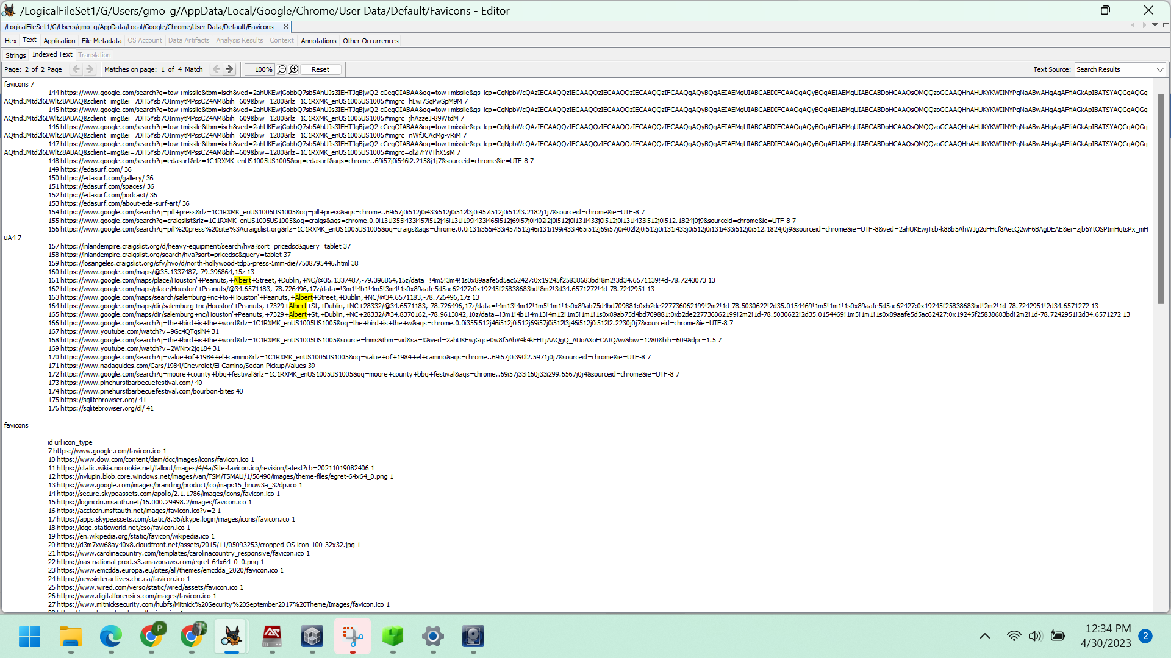

There is a hyperlink provided which leads to Google Maps.

https://www.google.com/maps/place/Houston'+Peanuts/@34.6571139,-78.7268822,17z/data=!4m6!3m5!1s0x89aafe5d5ac62427:0x19245f25838683bd!8m2!3d34.6571139!4d-78.7243073!16s%2Fg%2F11cjgb45bb

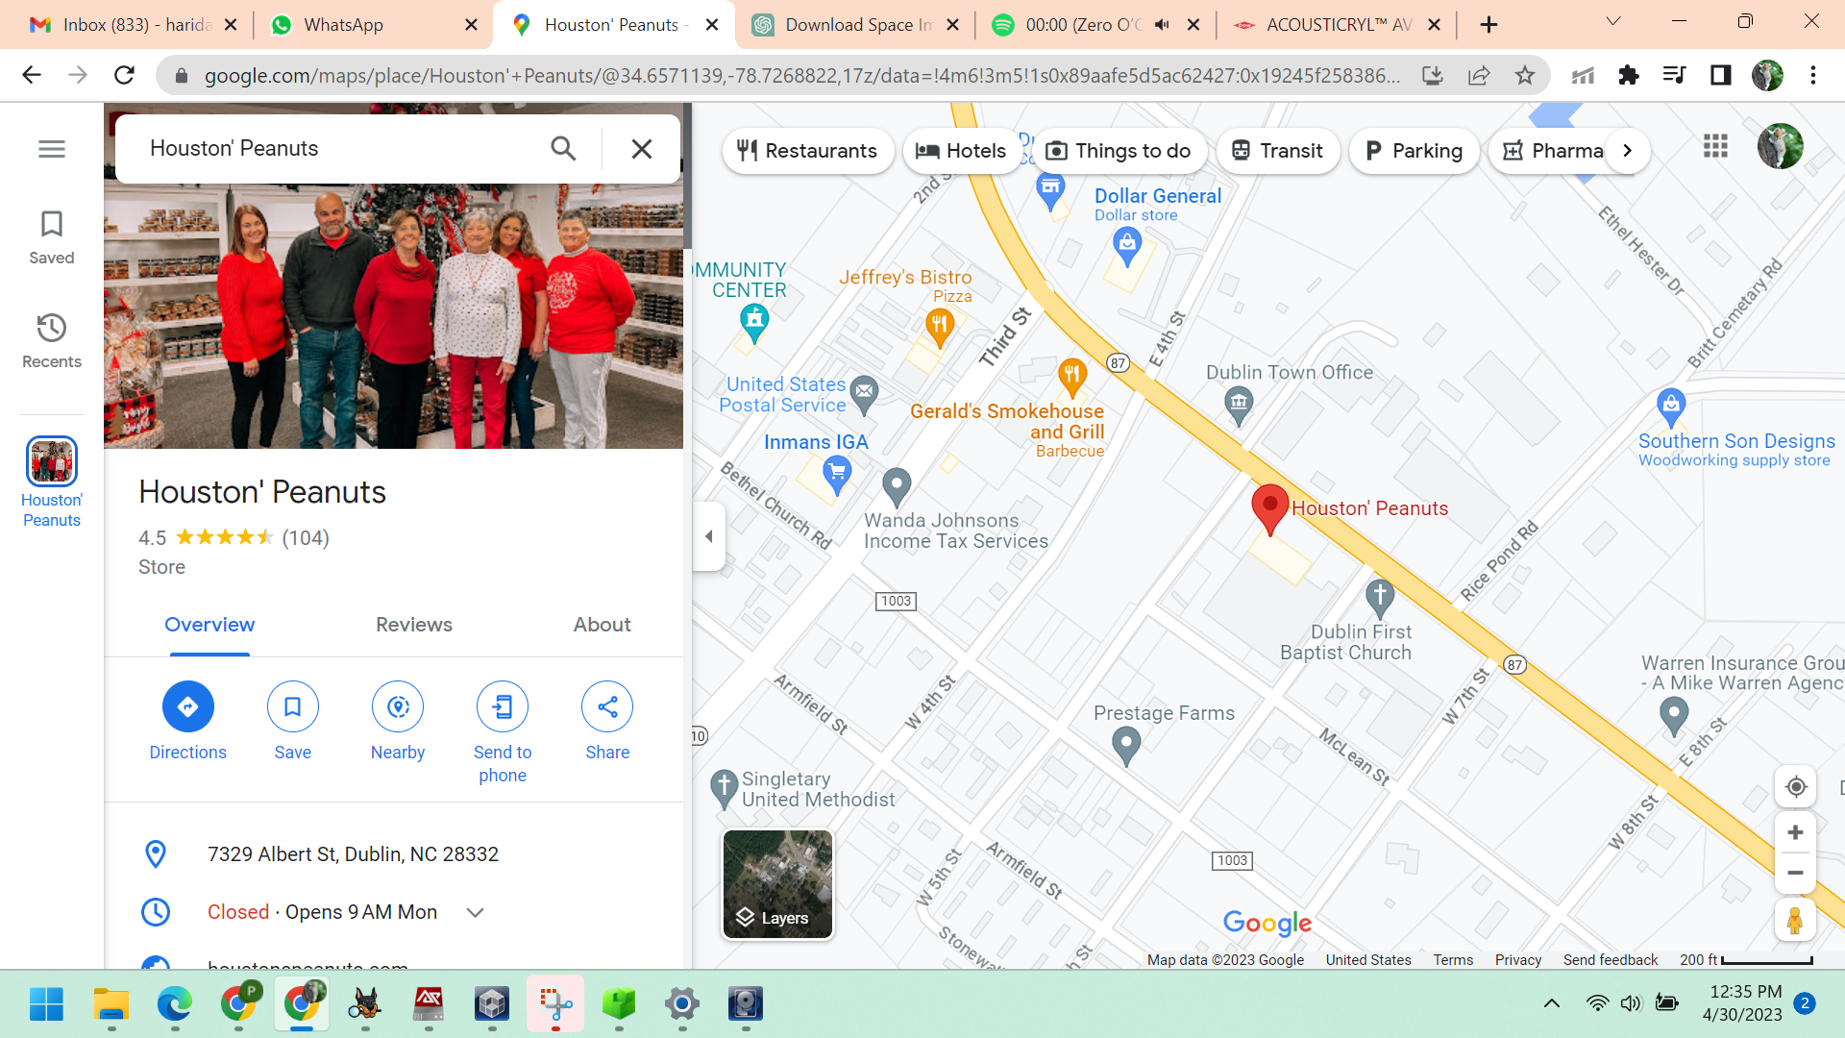

*Figure: Verification of the hyperlink.*

There is a single PDF document named RettGetPress.pdf, which can be found at File Views -> File Types -> By Extension -> Documents -> PDF(3).

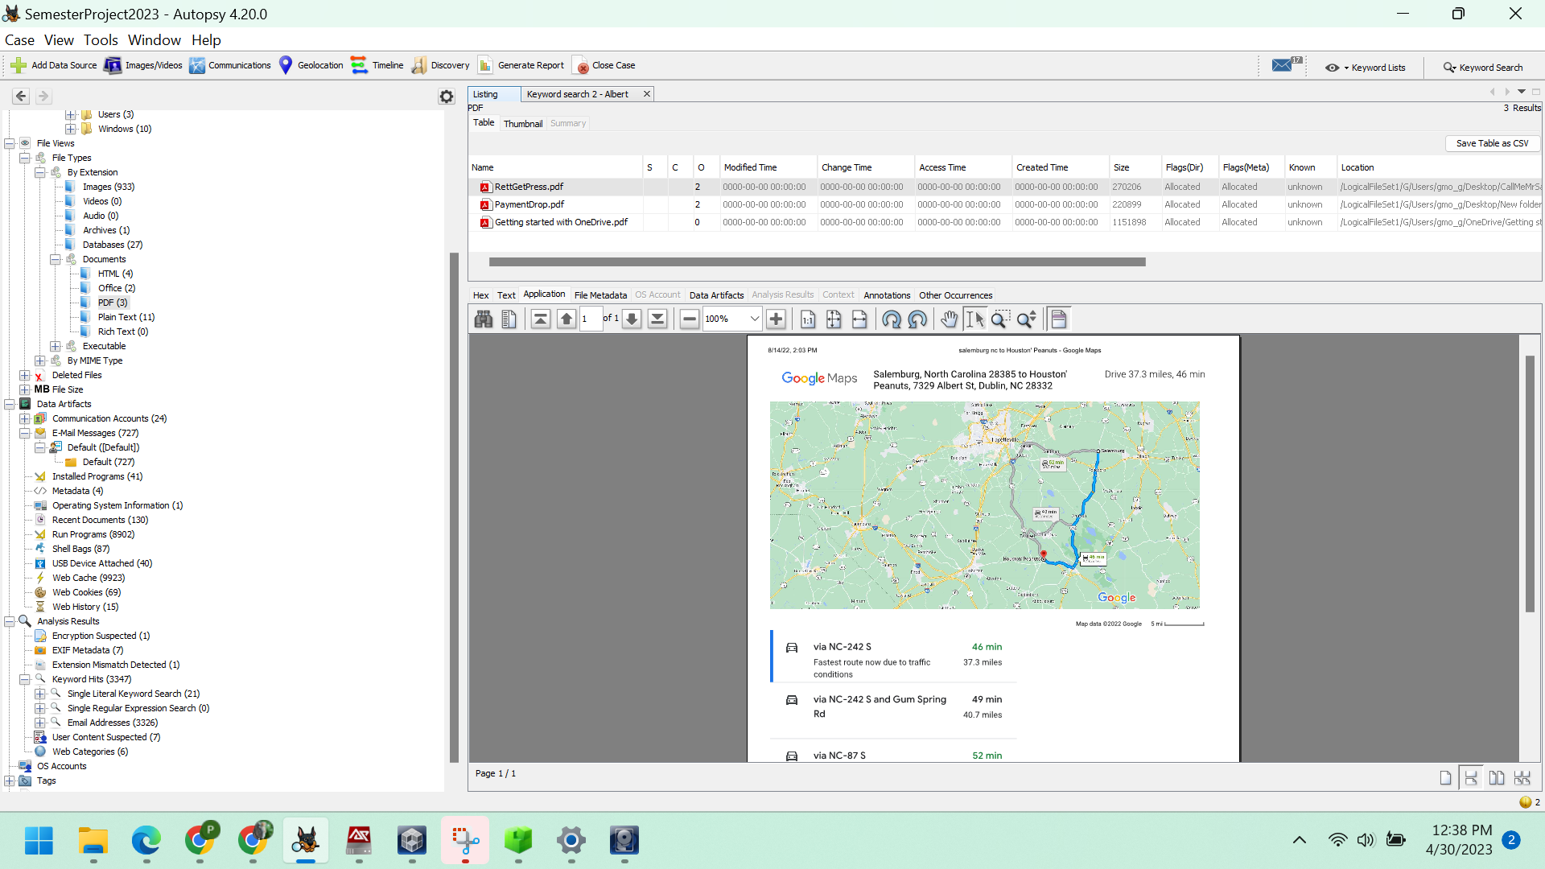

*Figure: PDF named RettGetPress*

3. The employees at Houston’s told Sheriff’s Deputies that Rett arrived in an old red truck. Rett asked for a lawyer prior to detectives asking him about his vehicle in use that day. Can you find any evidence on Gene’s computer about the truck Rett might have used? We know the two were in frequent communication and have an informant who said Rett likes to brag to Gene about any crimes he commits or is thinking about.

The pictures of an old vehicle can be found in the EXIF metadata section located at Analysis Results. There are a total of 3 images available.

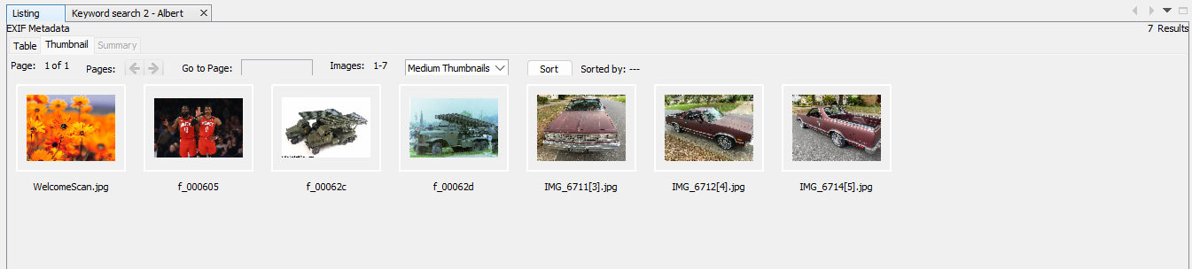

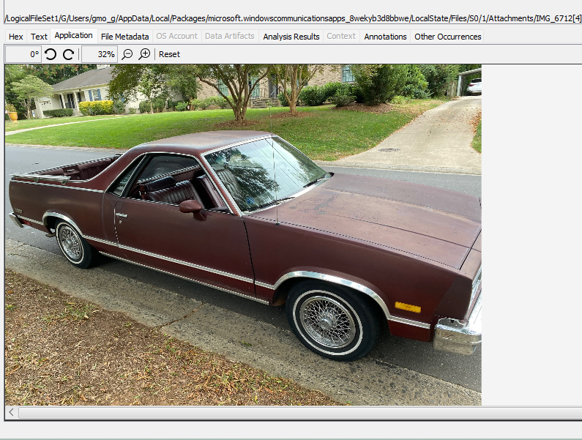

*Figure: Image of Vehicle.*

4. The truck may have been stolen as Rett often steals vehicles for use in his criminal activity. If you found a possible match, can you determine where the vehicle may have come from

To determine the location, we can select the GeoLocation option in the EXIF Files. The stolen item was taken from Sulkirk Road in Charlotte, North Carolina.

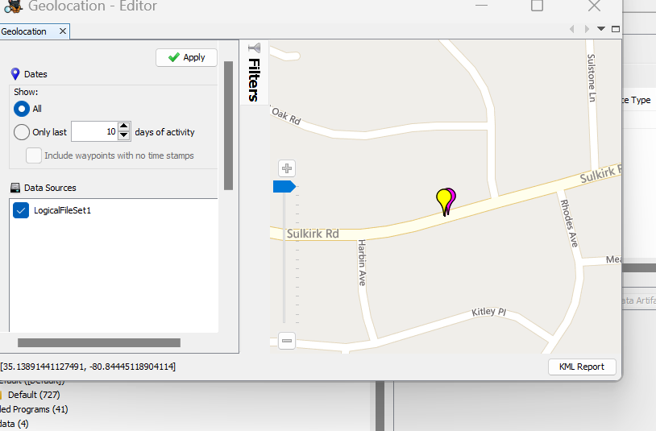

*Figure: Location of Vehicle stolen*

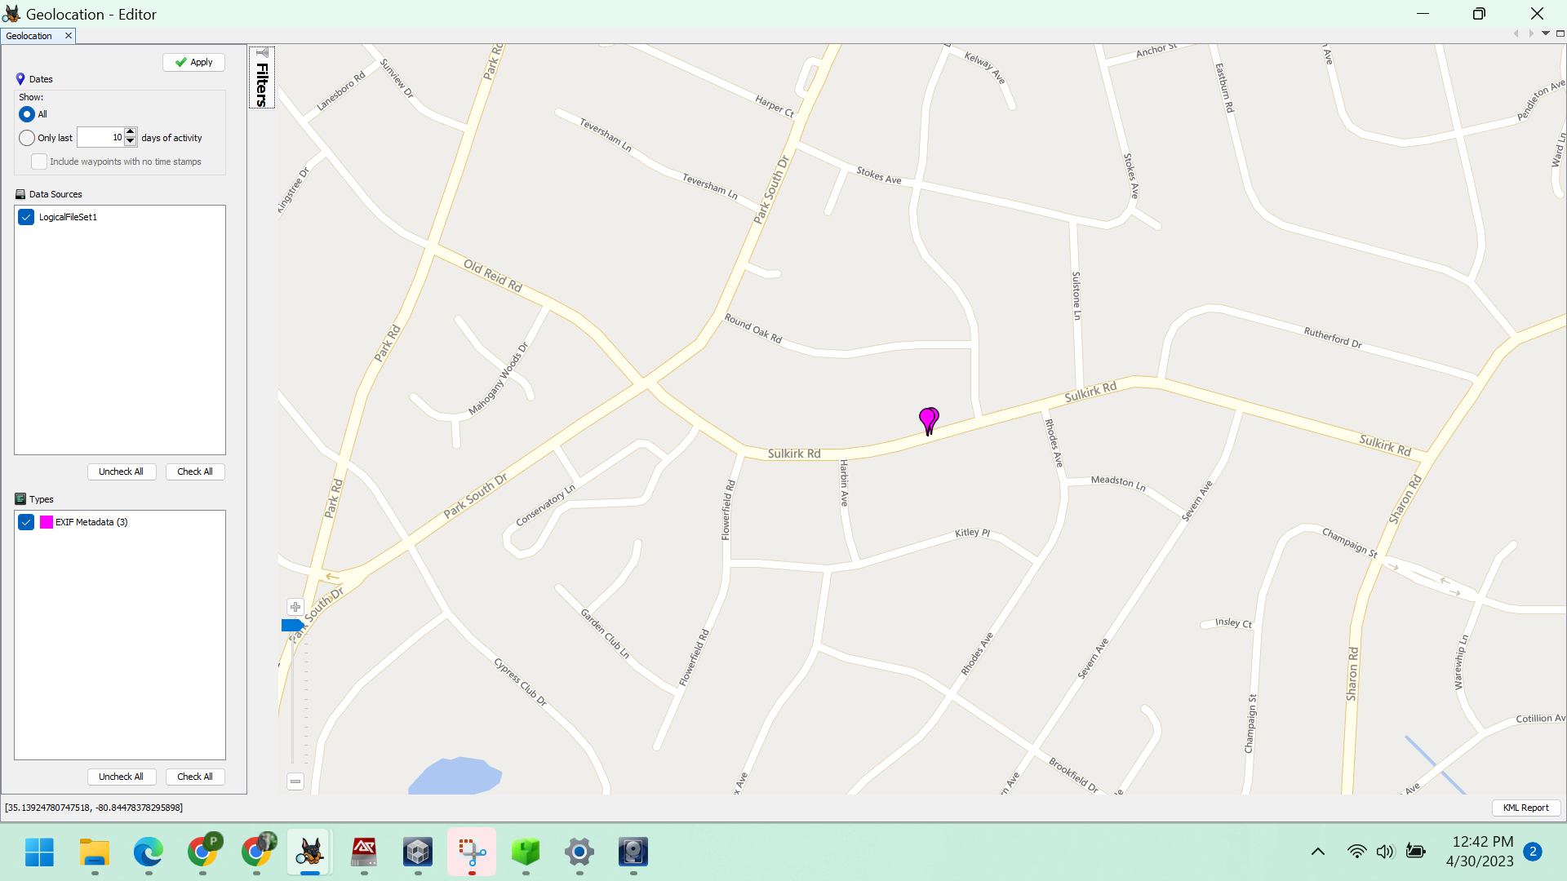

*Figure: Location of the vehicle*

5. Are there any photos of military rockets on his computer apart from web browser cache? If so, where. If not, where might they have been saved?

Go to Data Sources and navigate to LogicalFileSet_1. Under Host, select LogicalFileSet1, then choose G, followed by Users, and finally gmo_g-Downloads. You will find various pictures of satellites and rockets in that location.

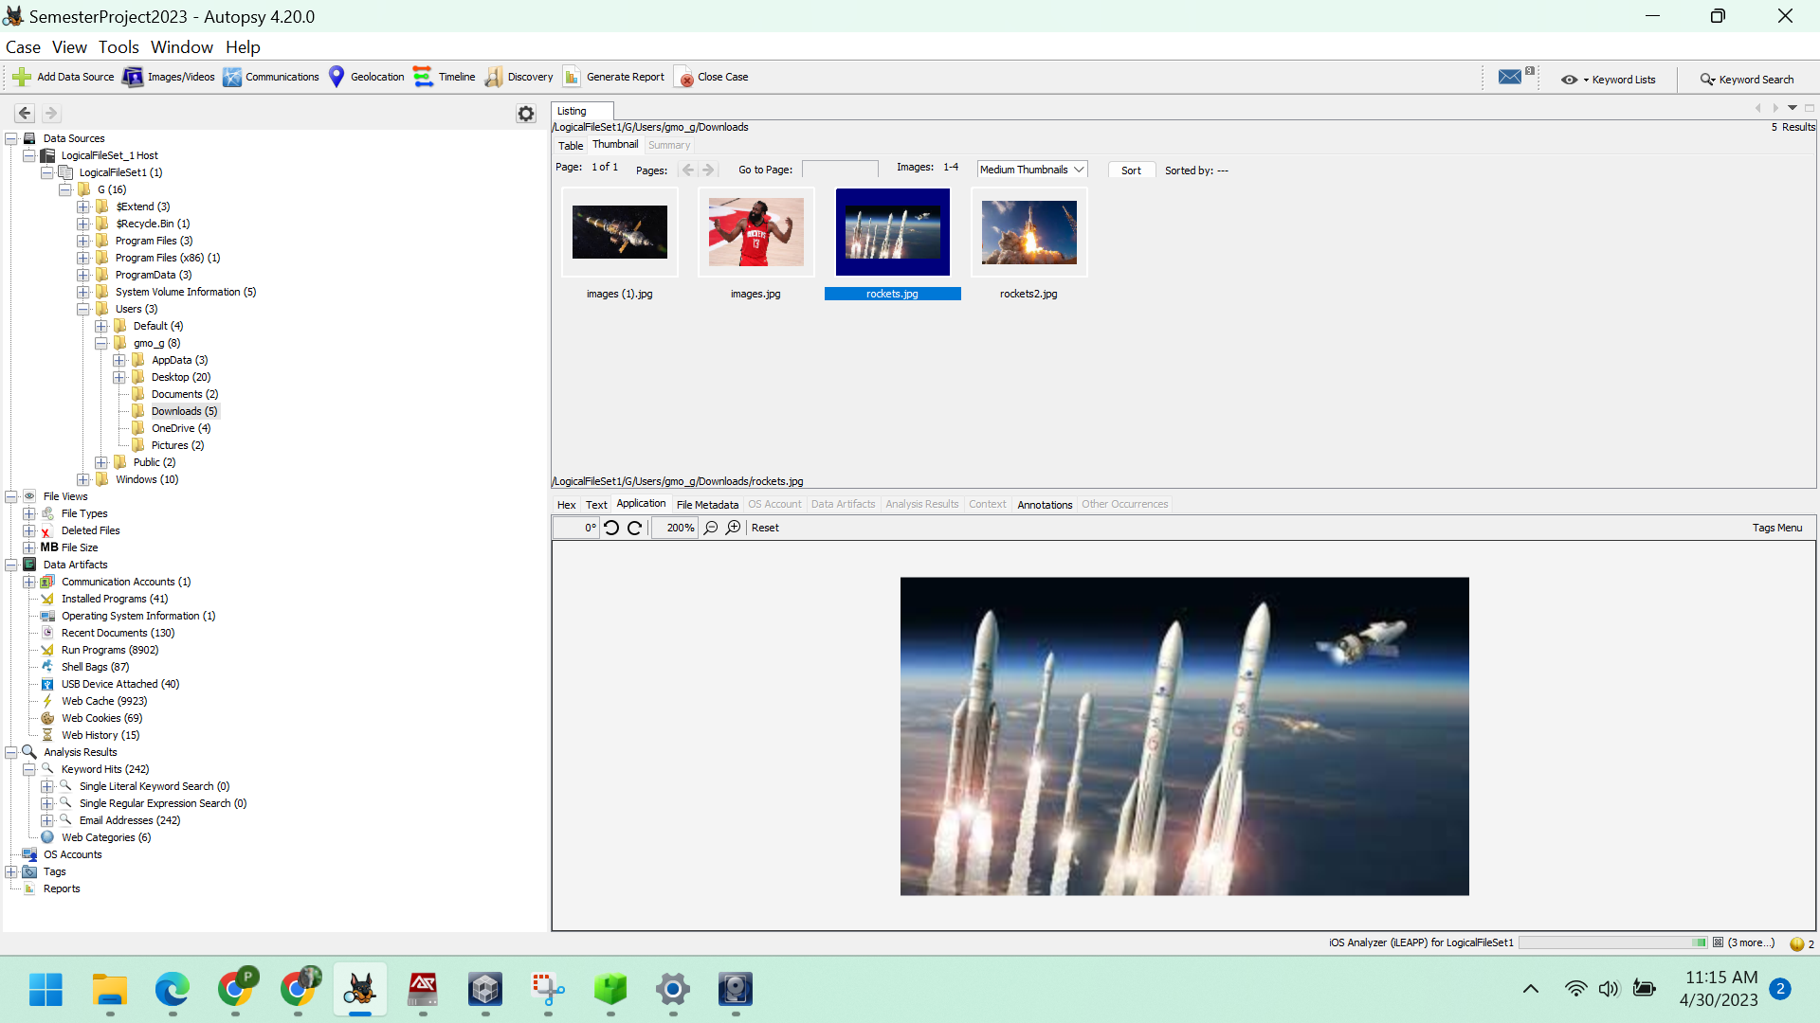

*Figure: Images of rockets*

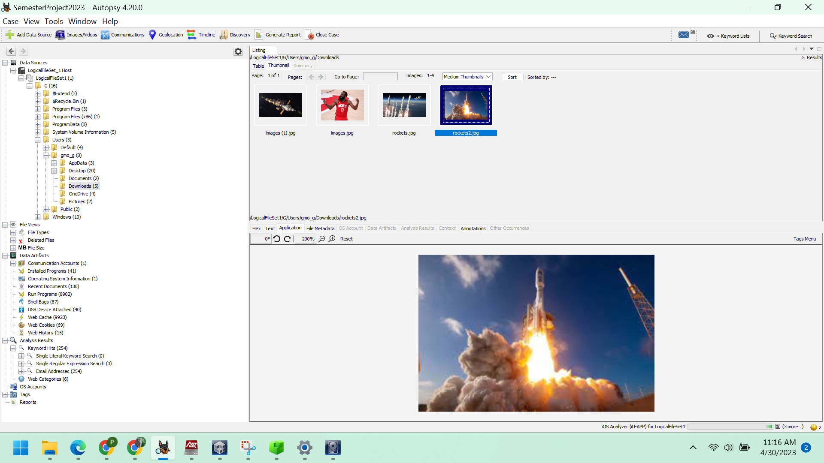

*Figure: Images of rockets*

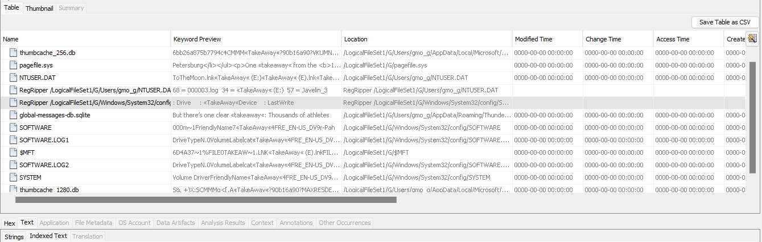

It can be observed that there is a shortcut called TakeAway(E).ink on the Drive.

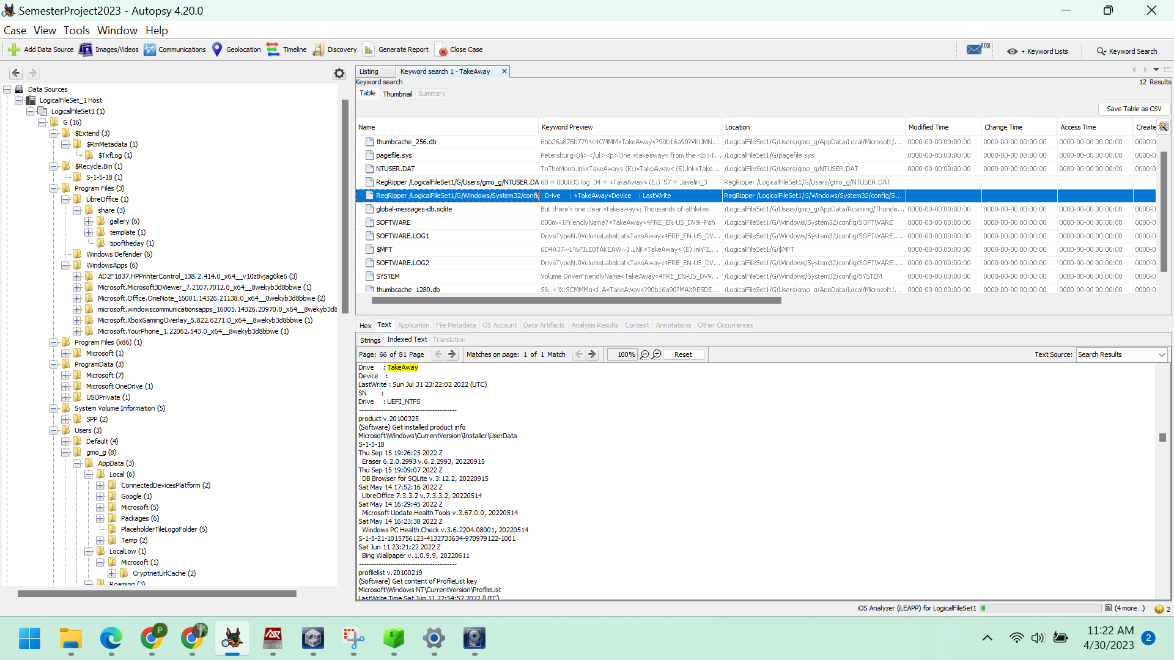

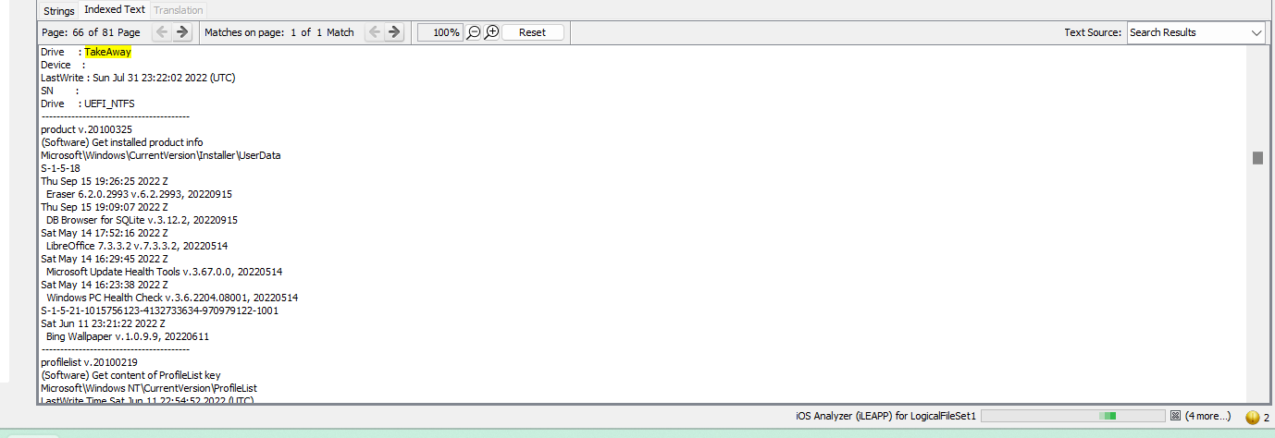

6. Has Gene discussed malware with anyone?

By navigating to Data Artifacts -> E-mail Messages -> Default -> Default, one can access the email correspondence.

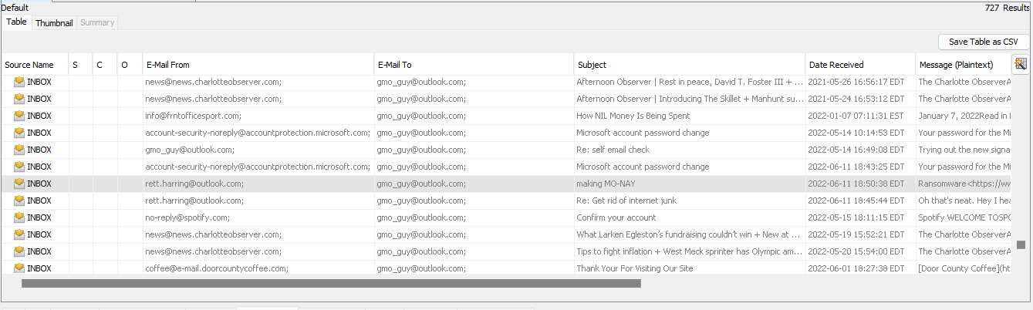

*Figure: Email Communications Identified*

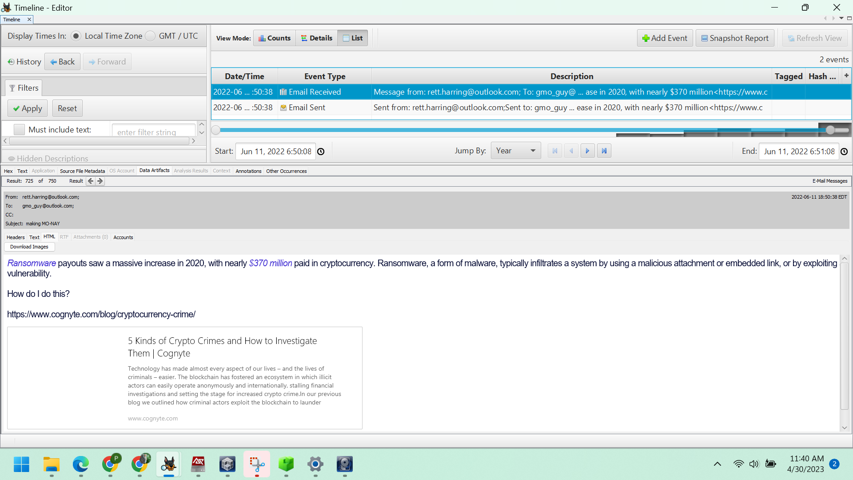

*Figure: Email Communications Identified*

The email in question was sent by rett.harring@outlook.com to gmo_guy@outlook.com, and its subject line was "making MO-NAY".

7. Are there any hidden lists of chemicals you can find? Gene is known to hide his shopping lists after his first bust.

To locate the file PoetryInMotion.doc, navigate to Data Sources -> LogicalFileSet_1 Host -> LogicalFileSet1 -> G -> Users -> gmo_g -> Documents.

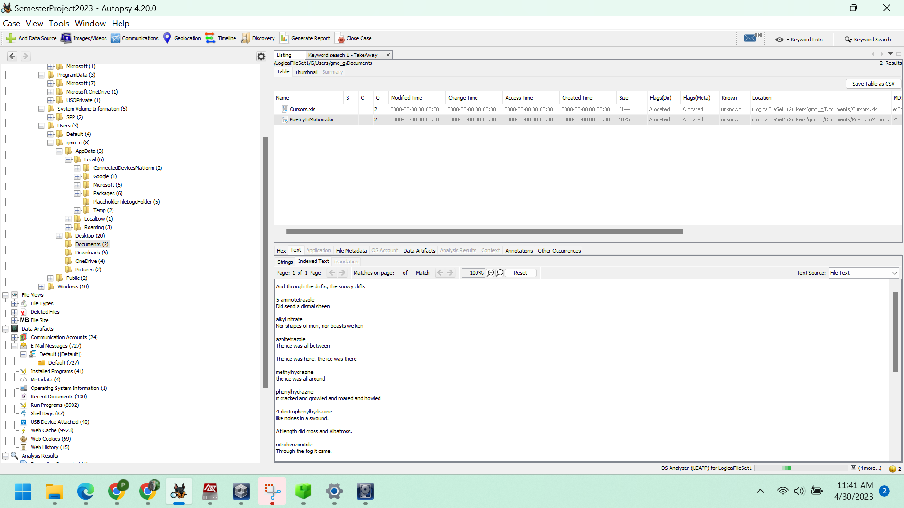

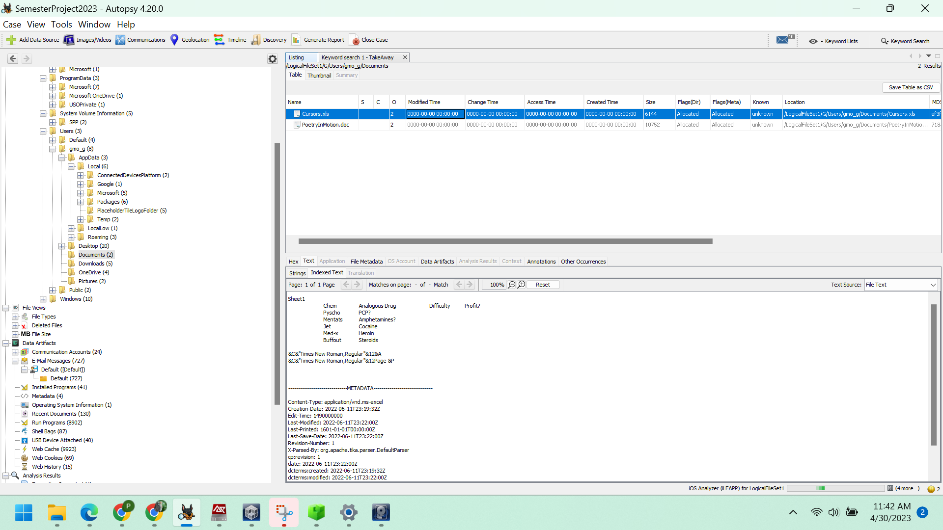

*Figure: File that contains chemicals and drugs list.*

There is evidence of an email conversation between Gene Poole and Rett Harring, which is related to chemicals, based on the subject line.

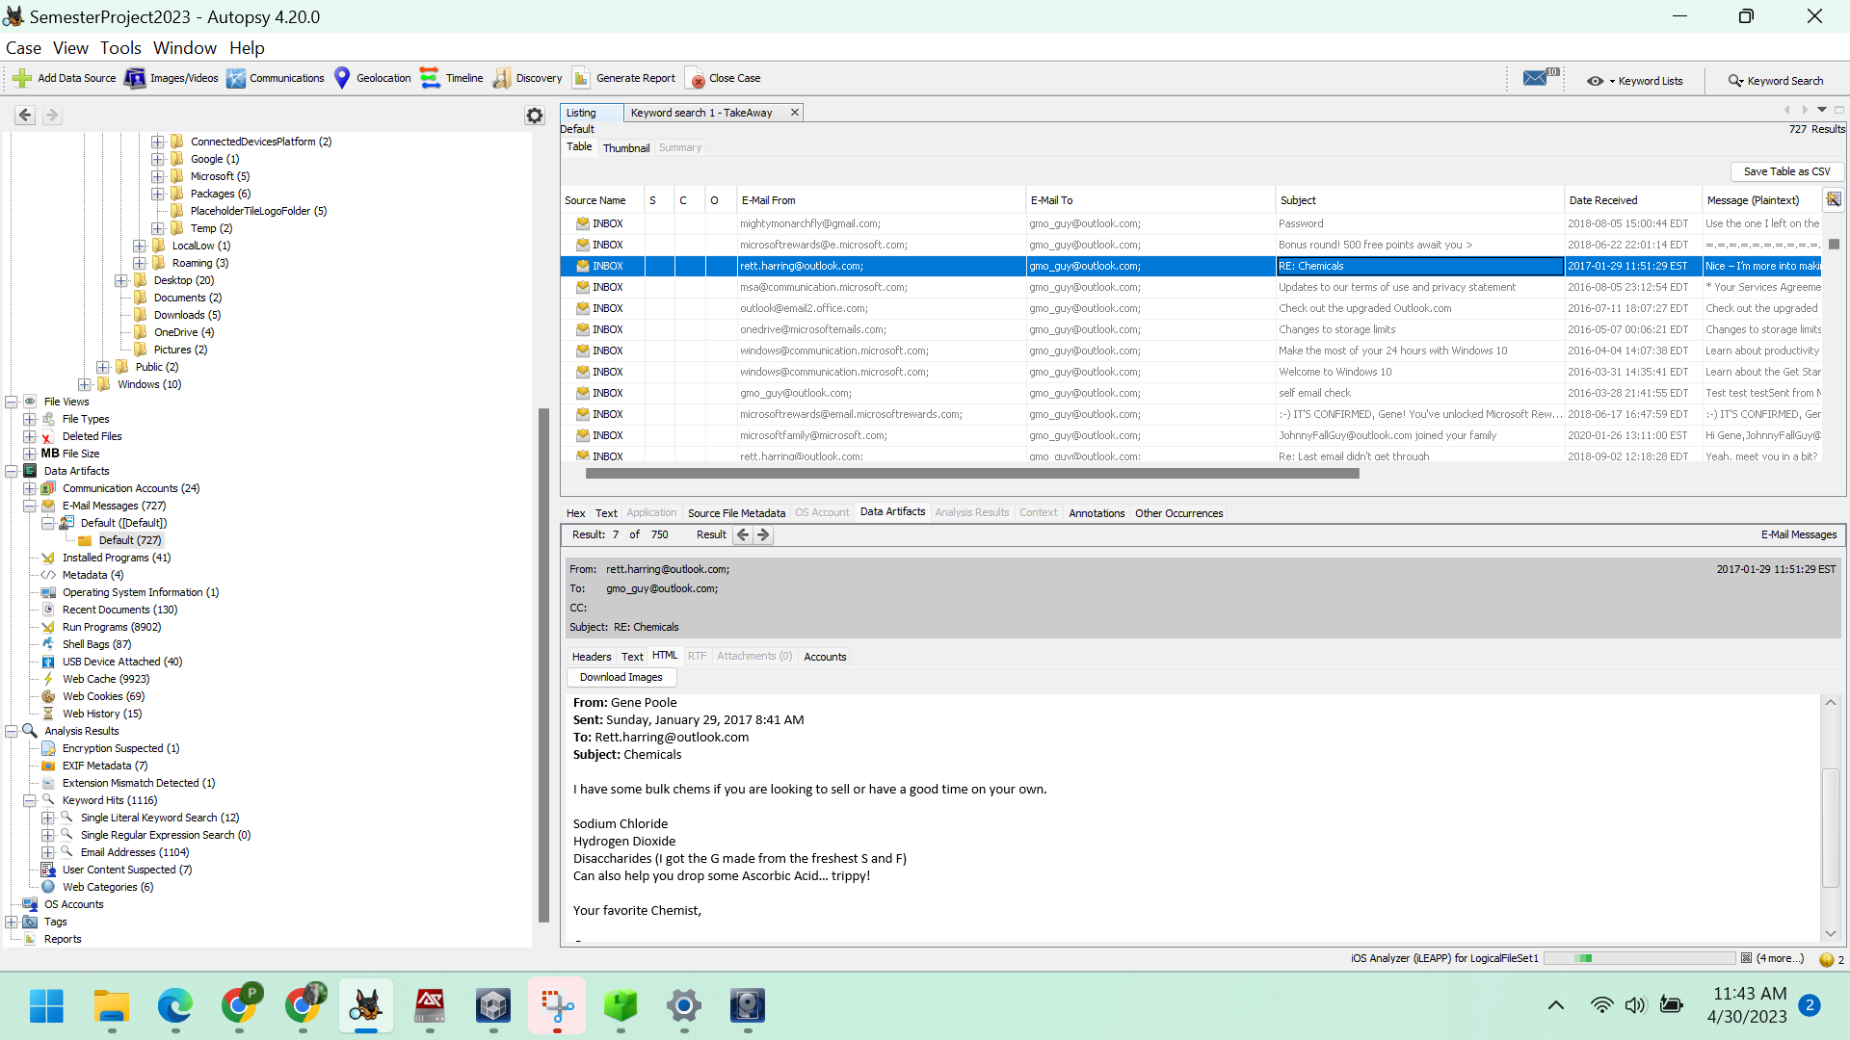

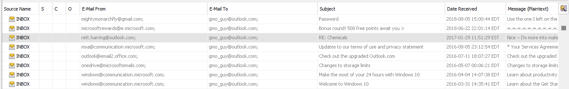

8. Where was Gene going to drop the payment to Rett?

To find PaymentDrop.pdf, go to File Views -> File types -> By Extension -> Documents -> PDF(3).

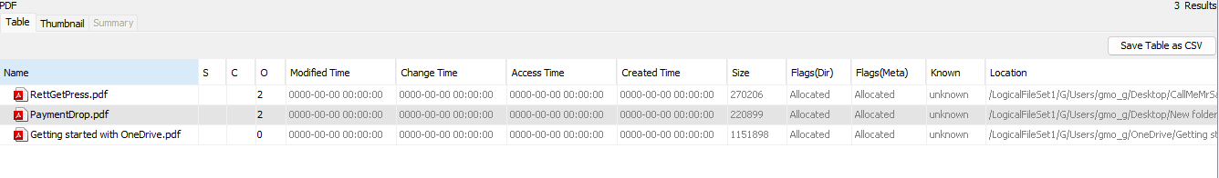

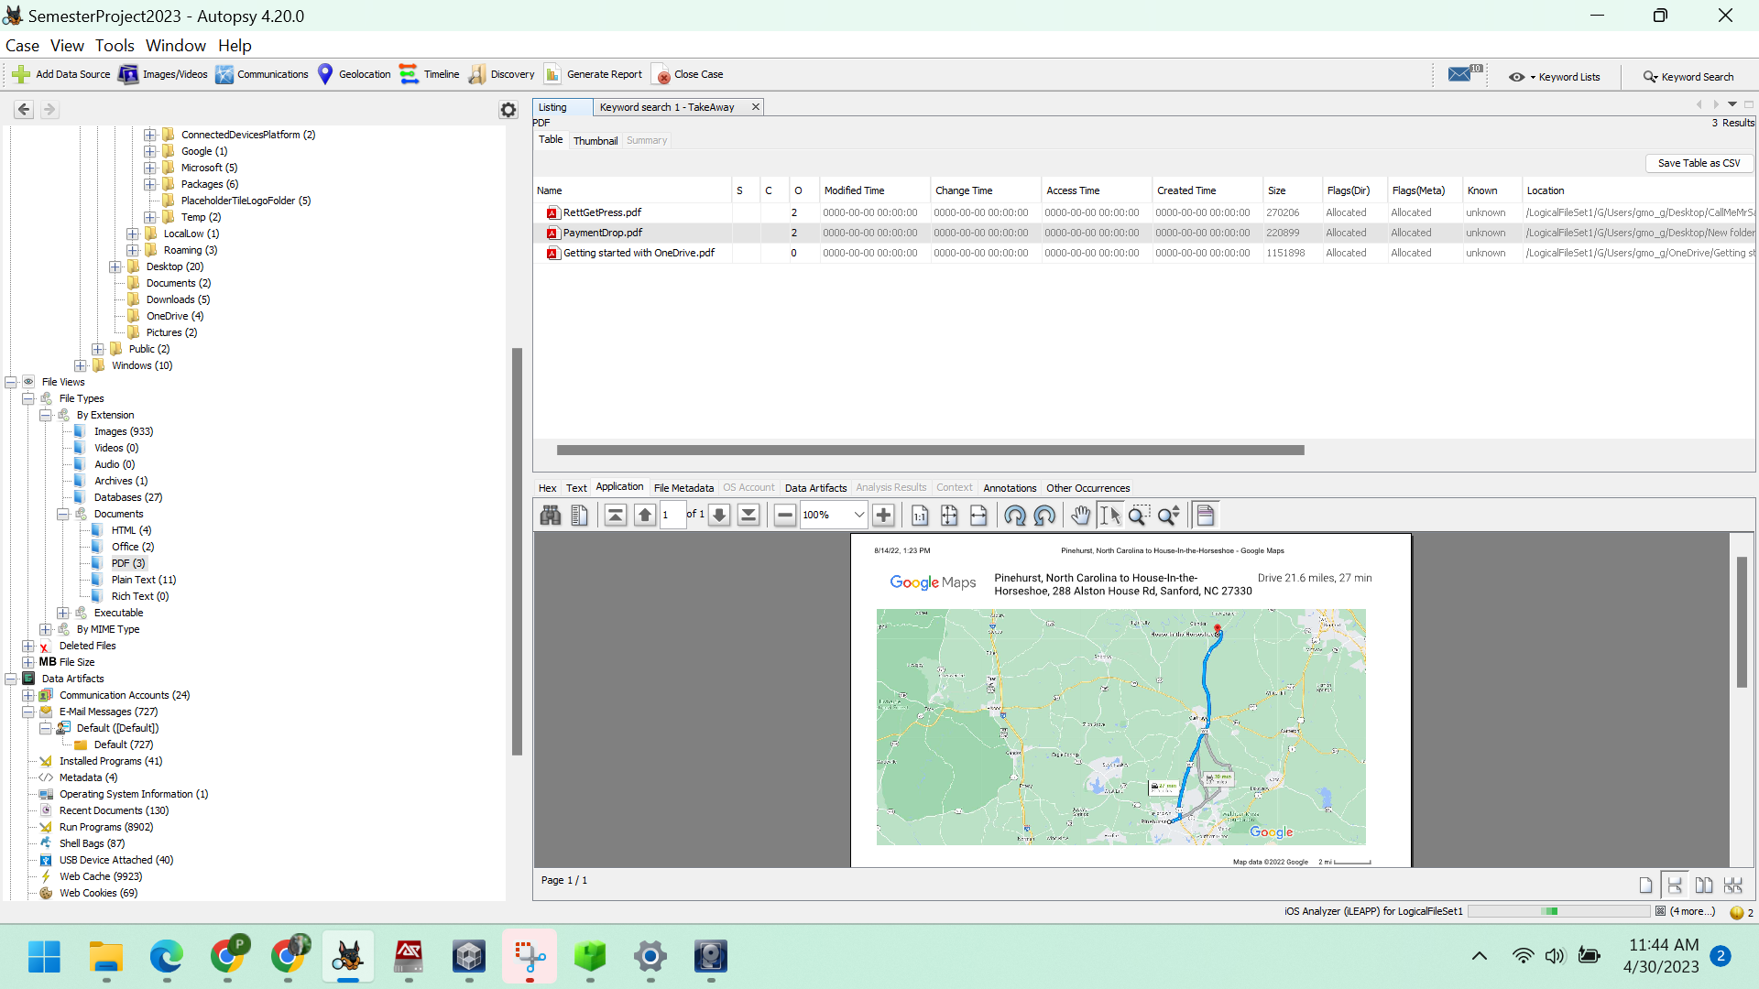

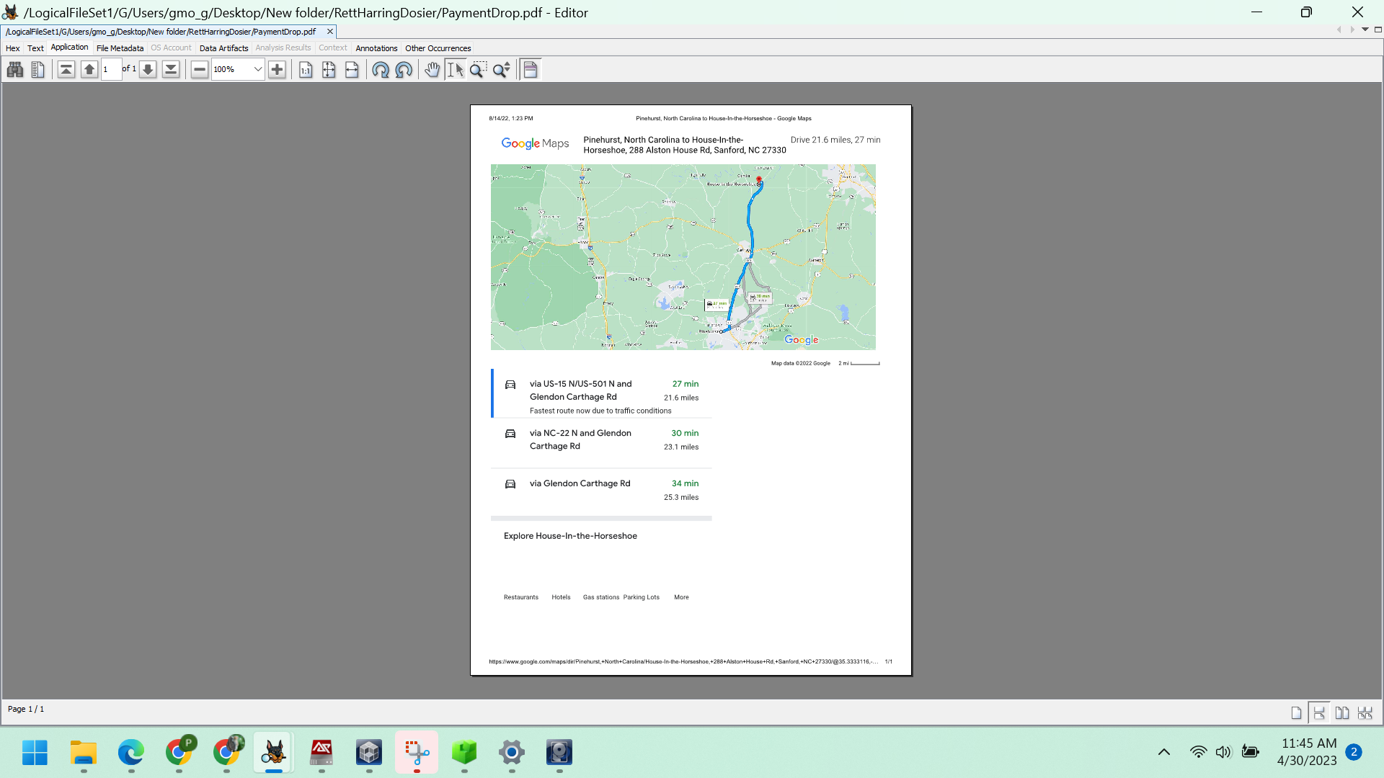

*Figure: Document of PaymentDrop.pdf*

The map displays the path for traveling from Pinehurst to the drop-off spot at the House-in-the-Horseshoe location*.*

9. Gene denies obstructing justice. Does he have any anti-forensics tools installed?

To determine whether any tools have been installed or not, check the Data Artifacts -> Installed Programs.

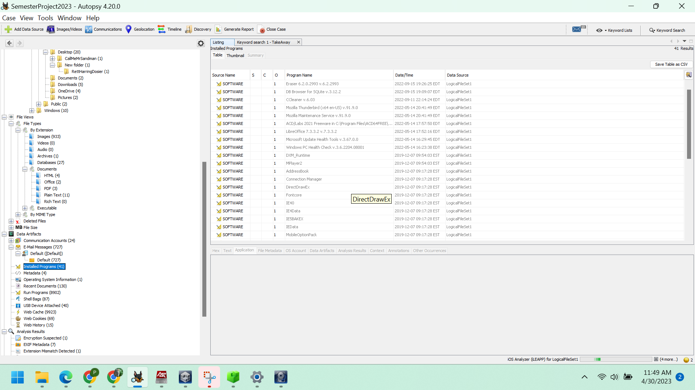

*Figure: Installed Programs*

Eraser 6.2.0.2993 v.6.2.2993 is a security tool

10. Has Gene run any anti-forensics programs?

By accessing Data Artifacts -> Run Programs (8902), it can be observed that Eraser.exe and Cleaner applications were executed several times.

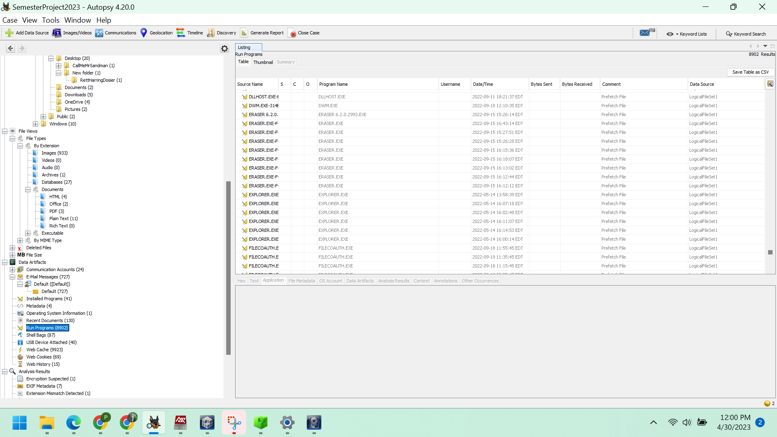

*Figure: portrays several instances of Eraser.exe, a security tool, being executed.*

11. Has Gene instructed anyone else how to do this?

By navigating to Data Artifacts -> E-mail Messages -> Default -> Default, one can access the email correspondences.

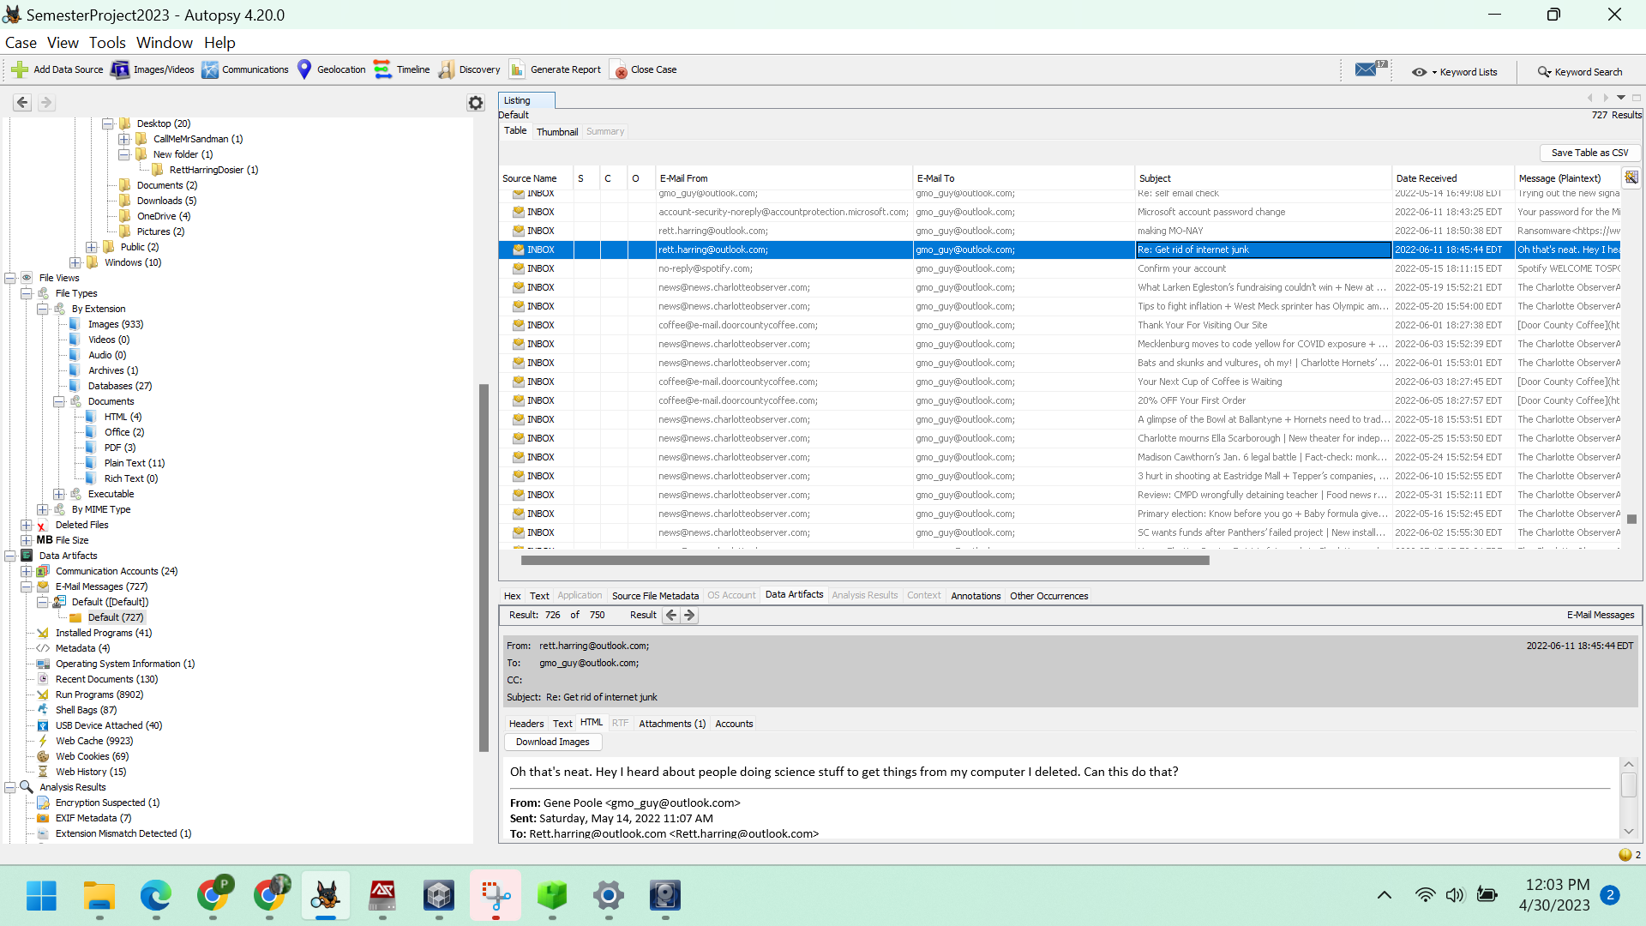

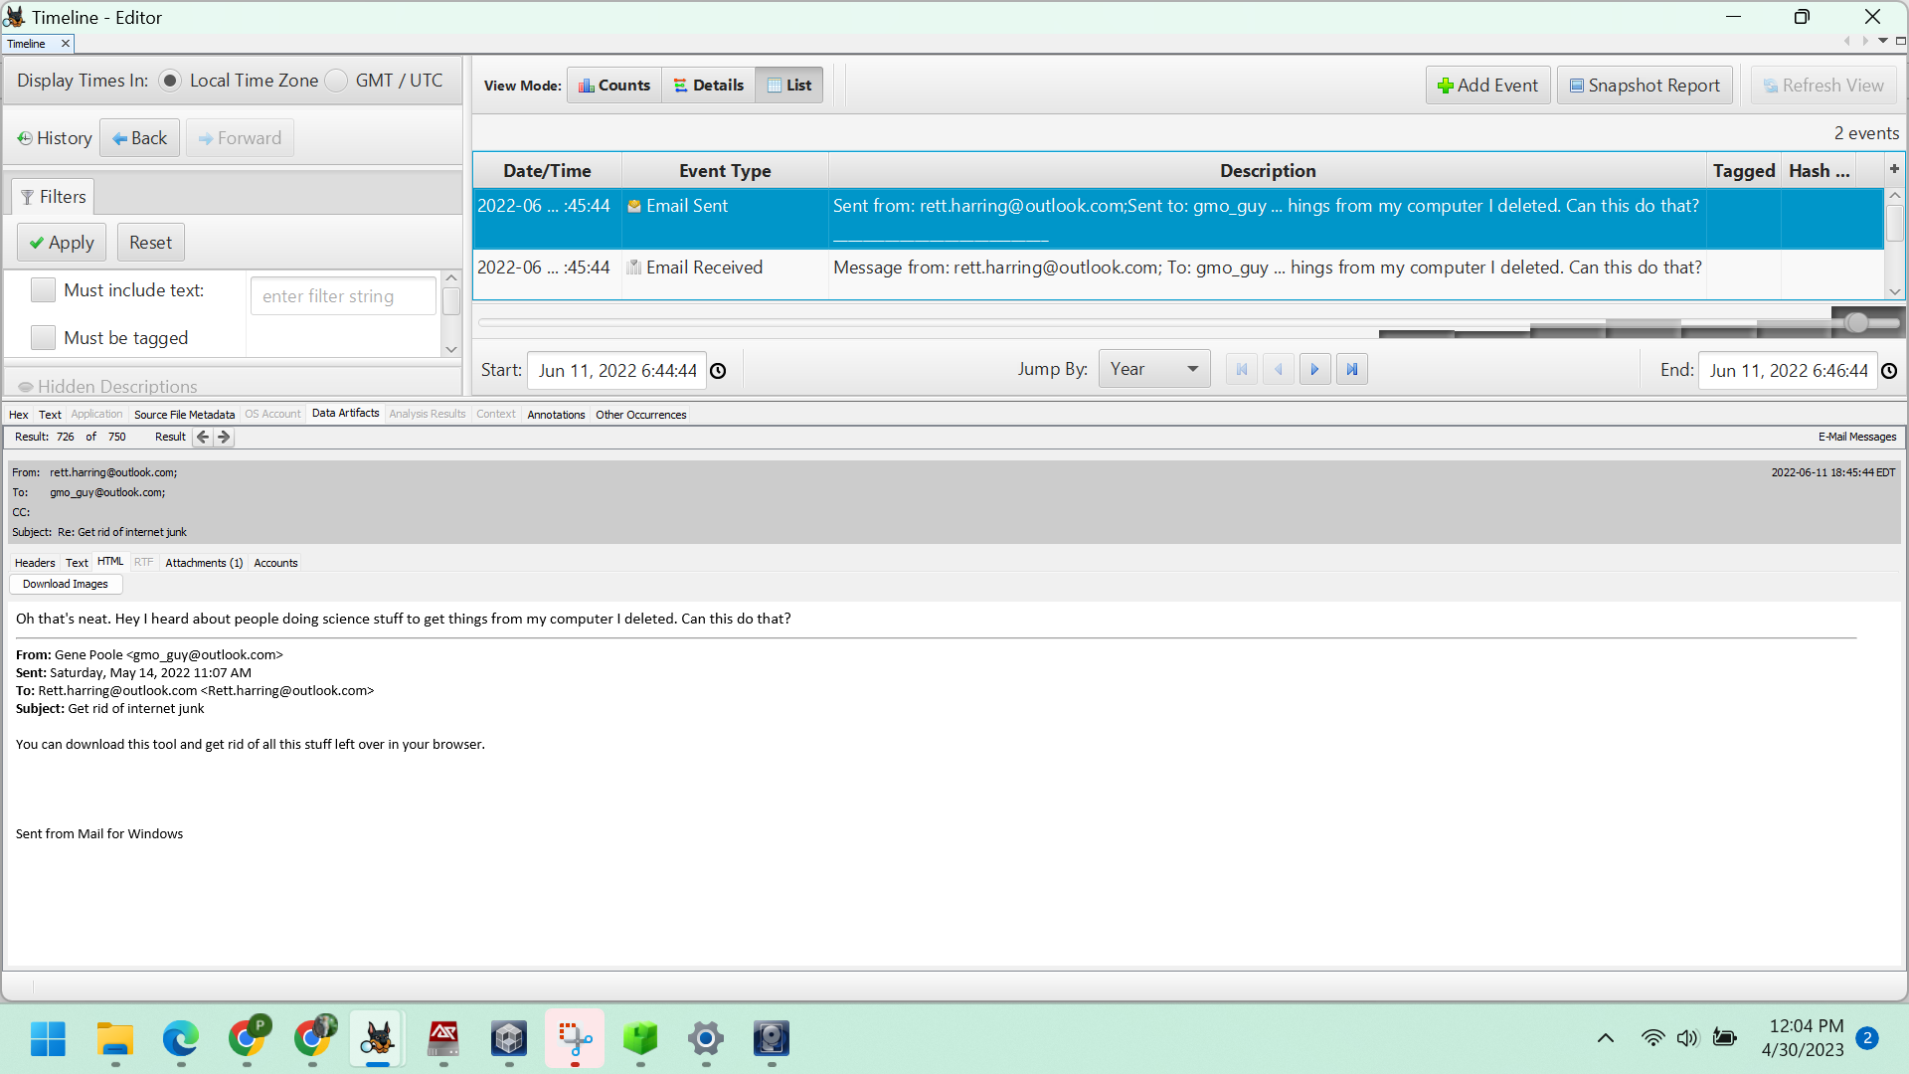

*Figure: Reply mail from Rett to Gene Pool*

12. Gene denies having used specific chemicals obtained from Dow, but admits he may have casually browsed their website. Is there anything more than browser history to suggest he might have saved information from Dow or intended to revisit their site later?

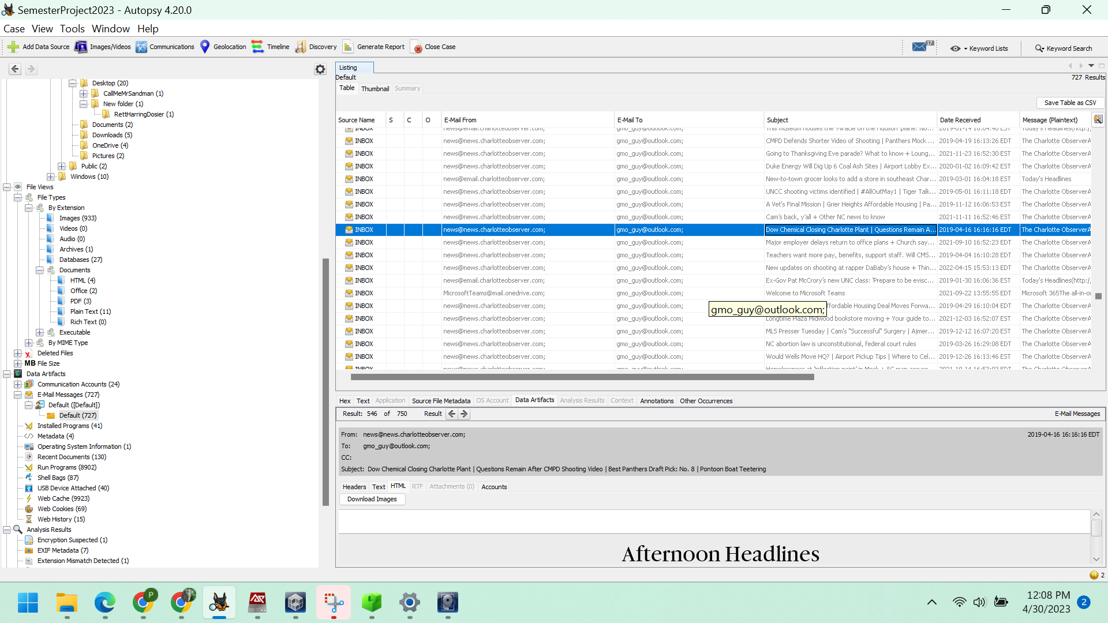

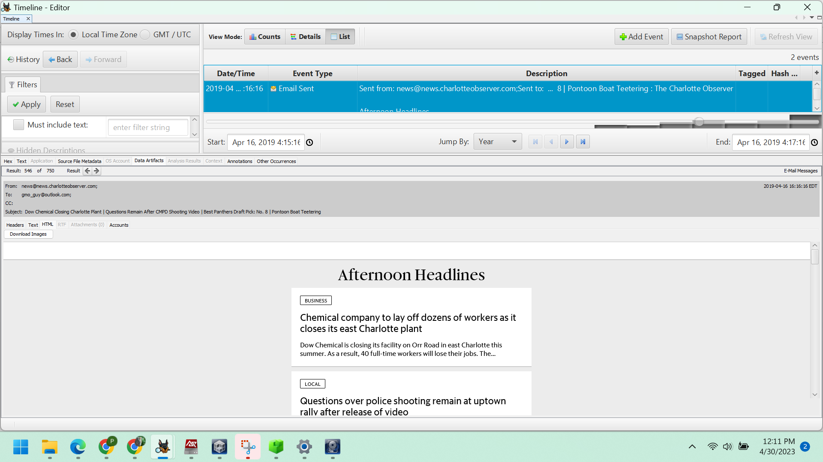

*Figure: Dow Chemical Closing Charlotte Plant*

In addition to these, there are two bookmarks that refer to Chemicals.

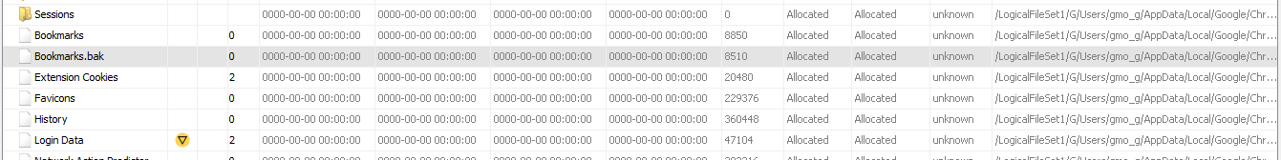

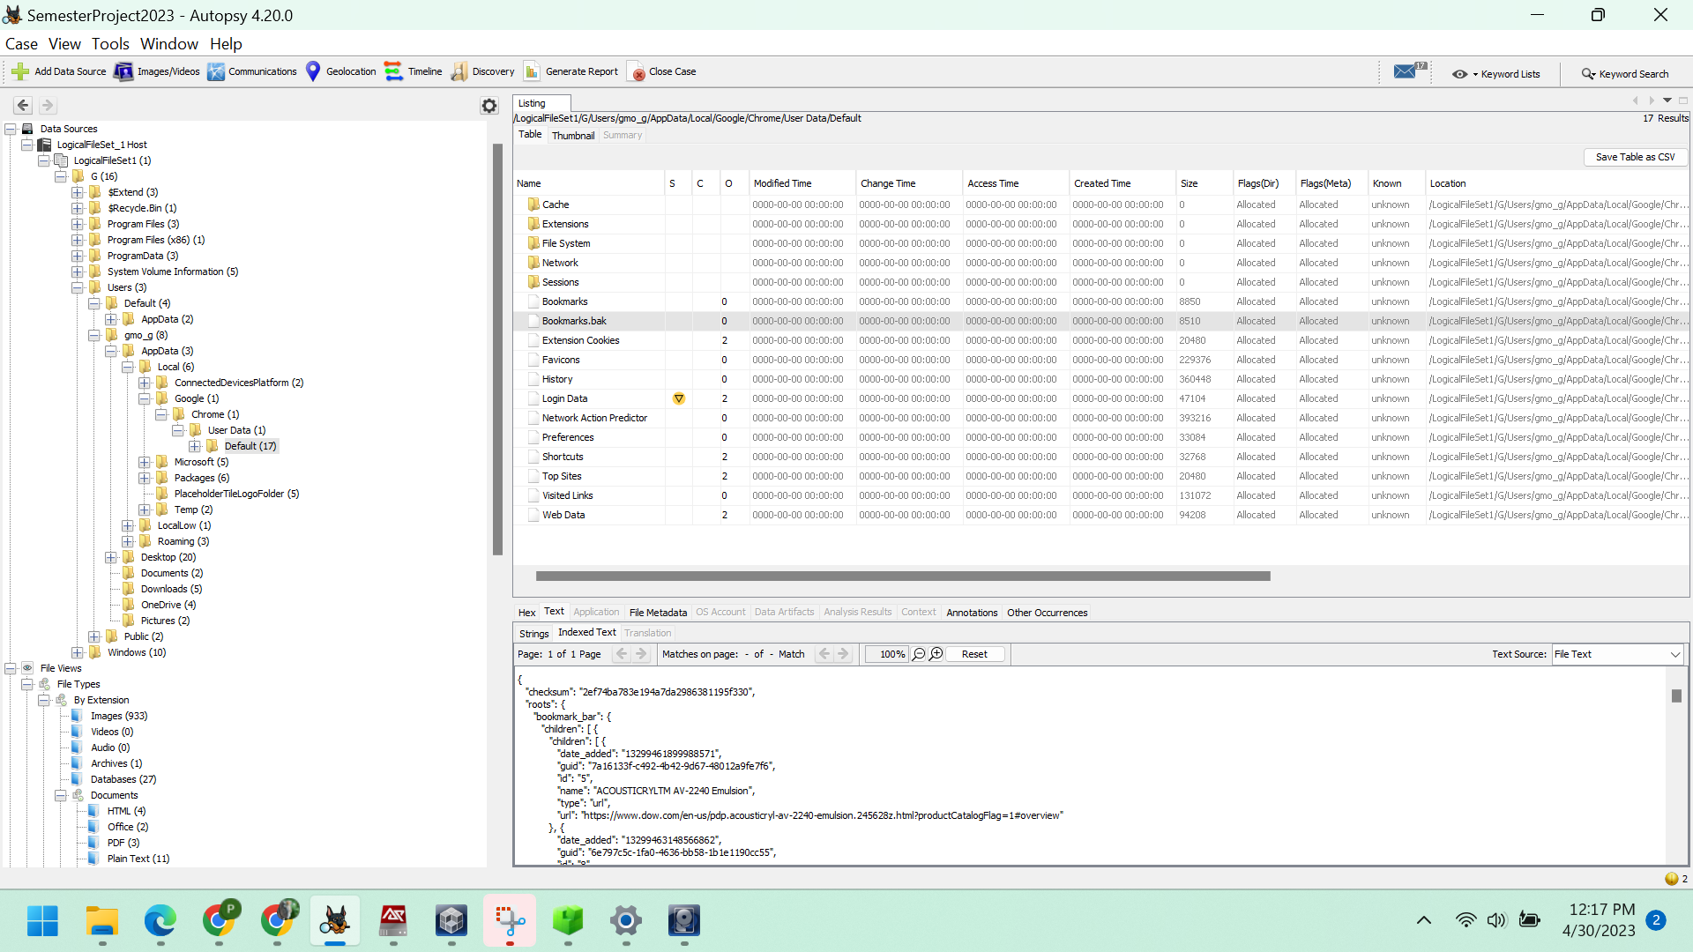

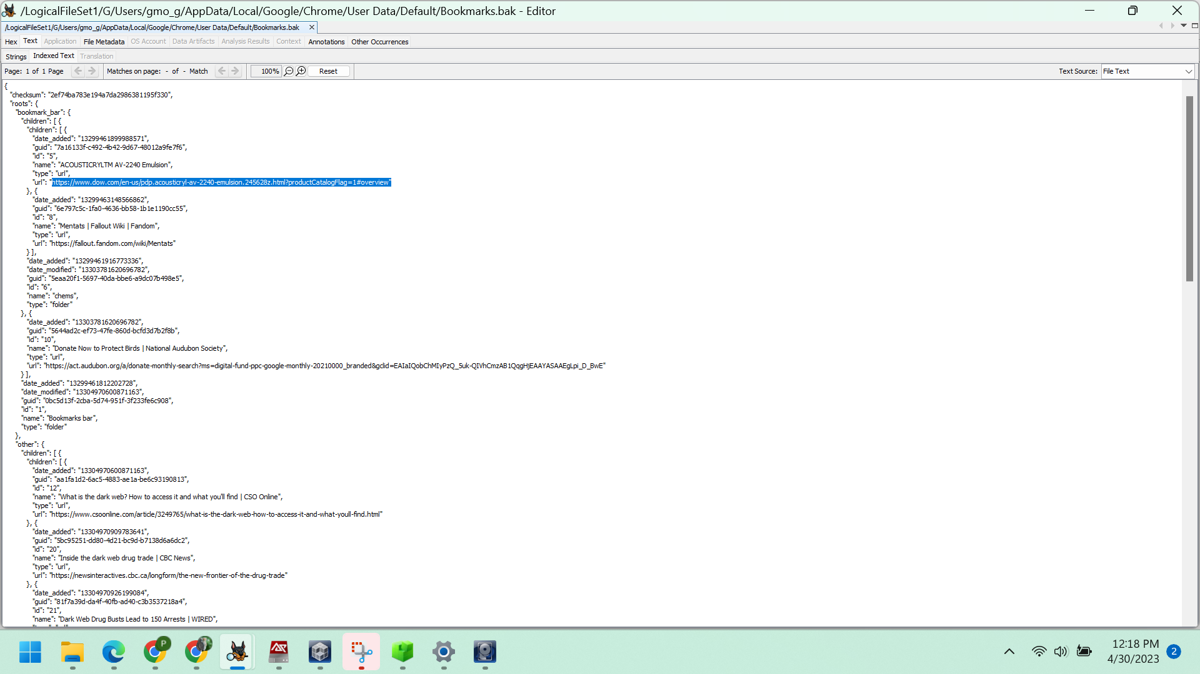

*Figure: Opened the Web Bookmark link in the timeline*

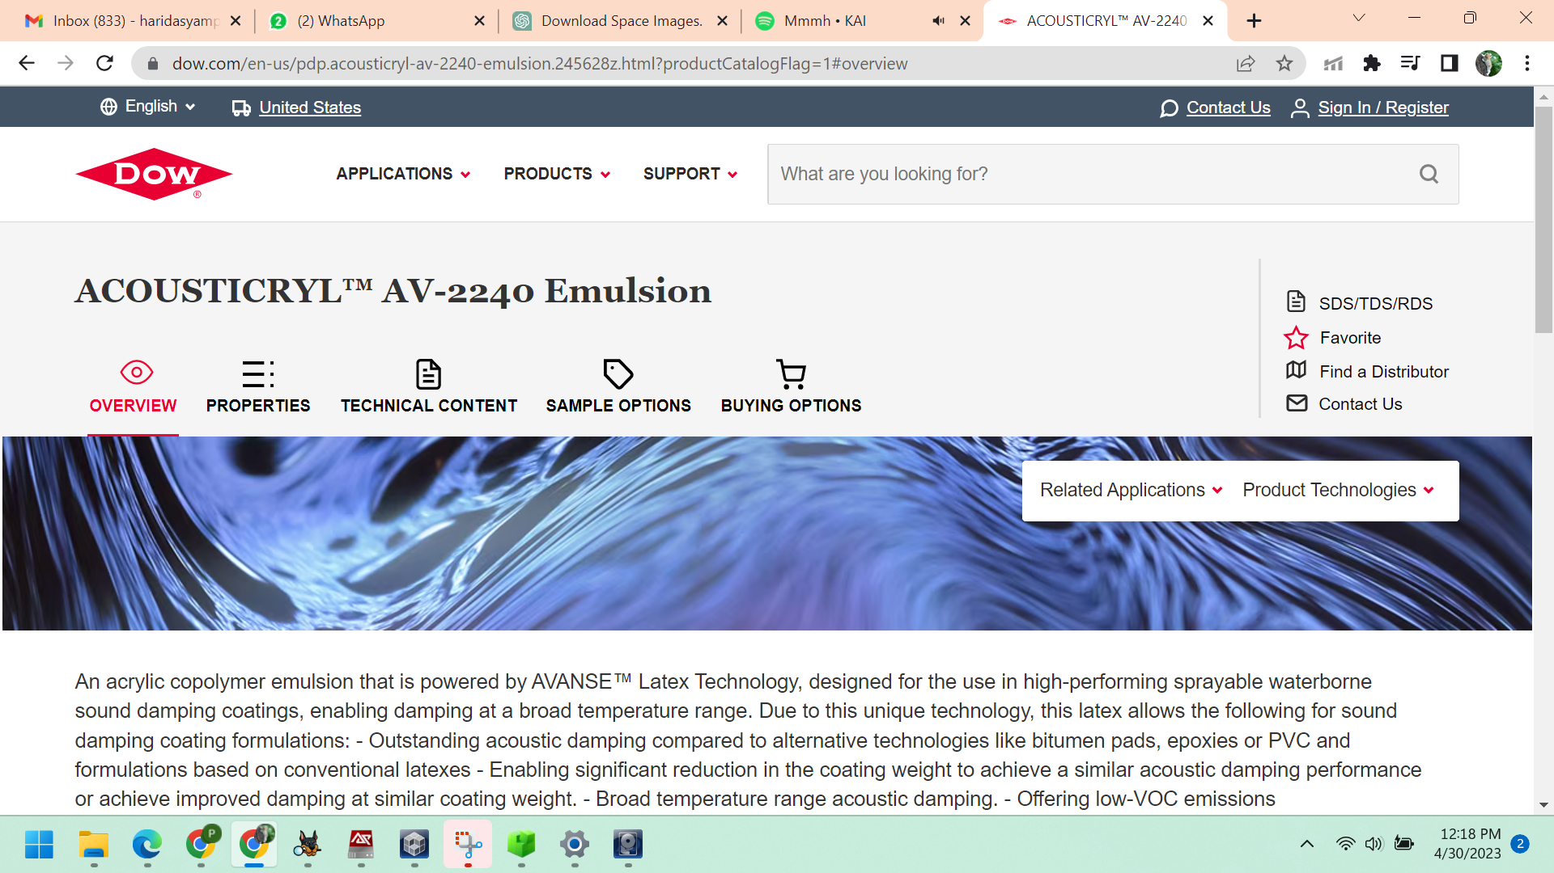

*Figure: opening of a web bookmark link within the timeline*

13. How many external storage devices were connected to the computer?

If you access Data Artifacts -> USB Devices Attached, you will observe that 40 of them have been connected externally.

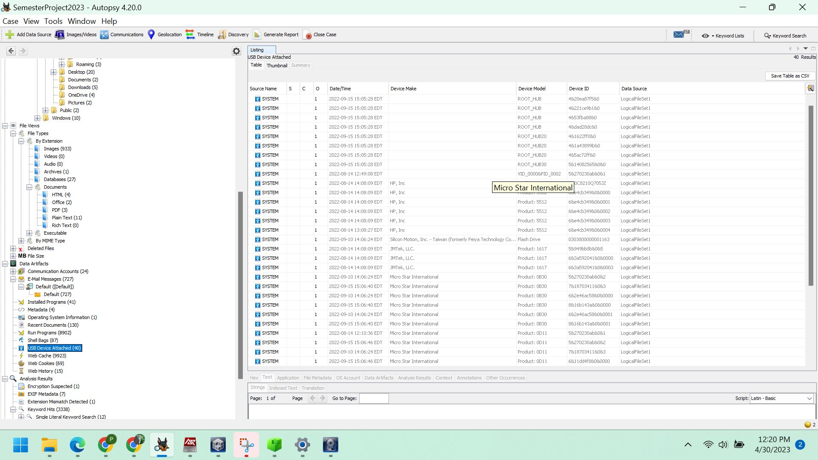

Figure: total count of external devices.

14. Can you recover the user tile for the main user?

AccessData Registry Viewer is utilized. Begin by accessing DataSources -> LogicalFileSet_1 Host -> LogicalFileSet1 -> G -> Windows -> System32 -> config -> SAM. Next, right-click on it and select "Extract files" and save them. Finally, open the SAM file in AccessData Registry Viewer.

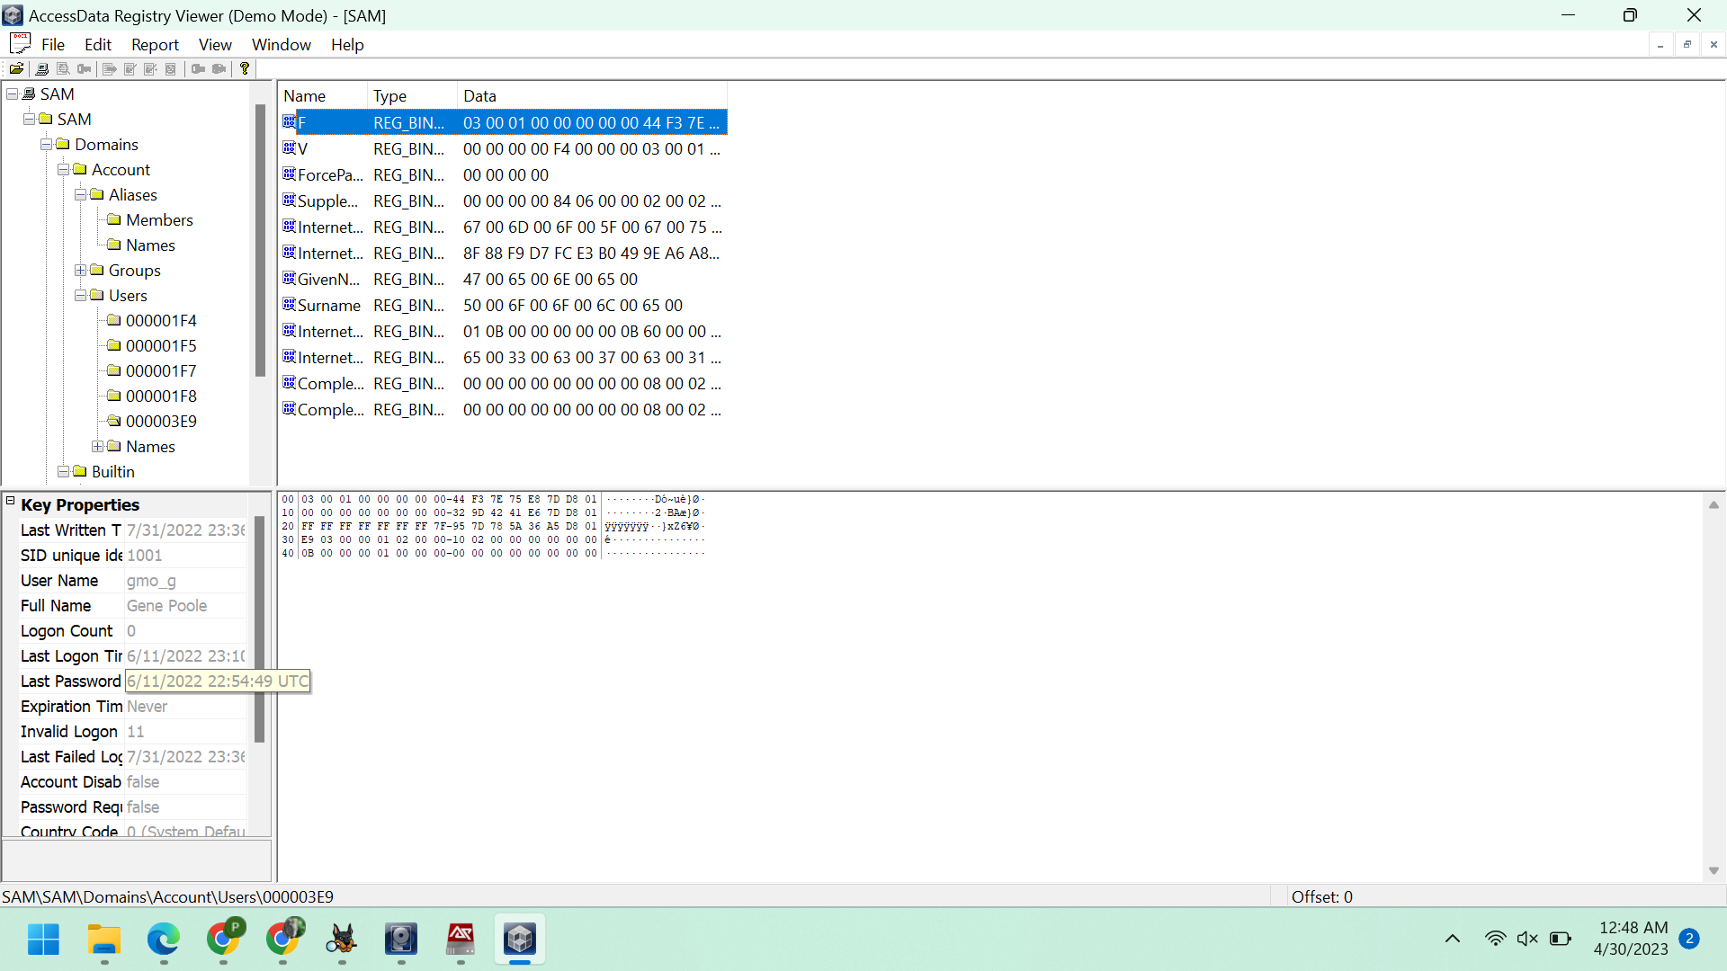

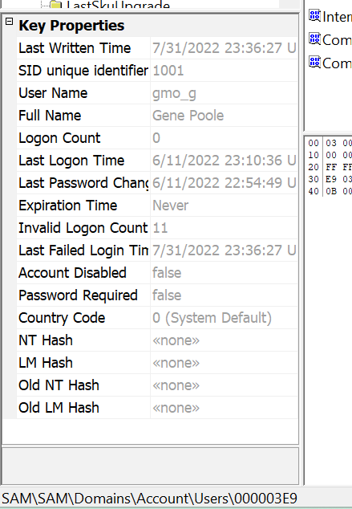

*Figure: SAM in Access data Registry Viewer*

By using this identification, we can retrieve the user's tile.

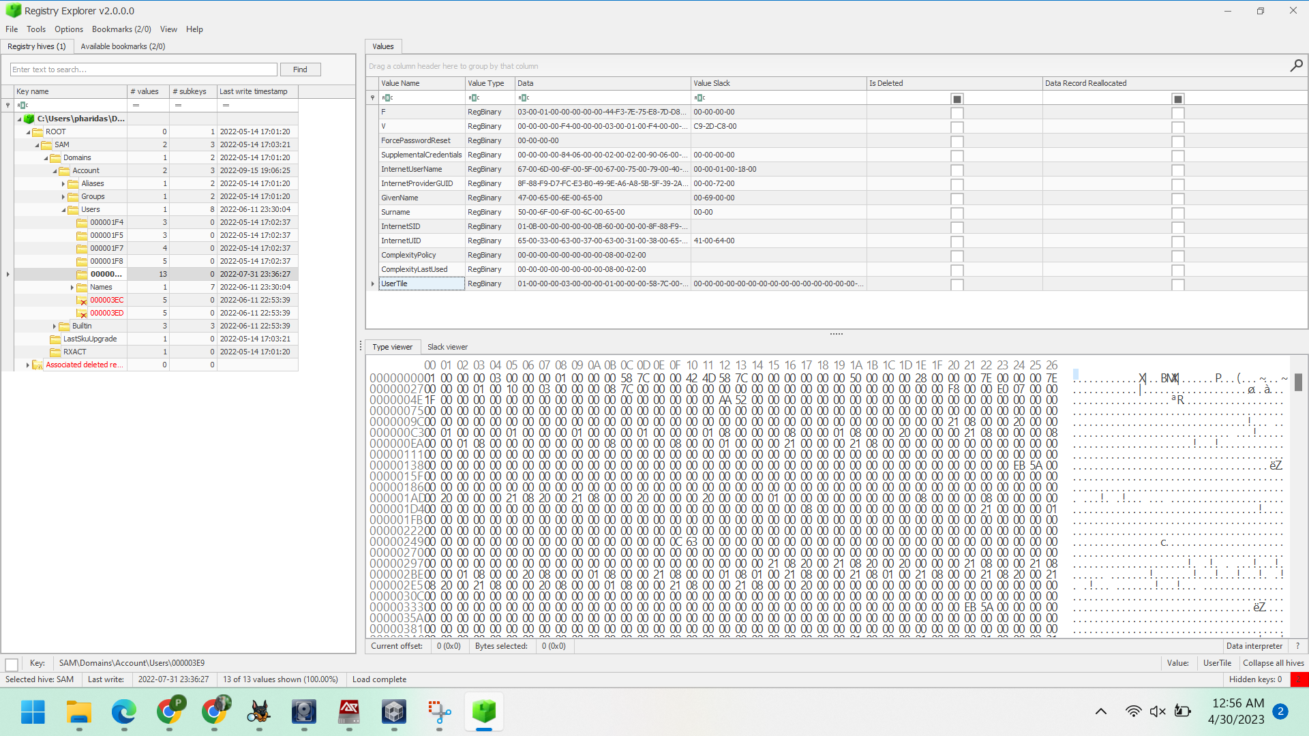

*Figure: Hex Value for User tile*

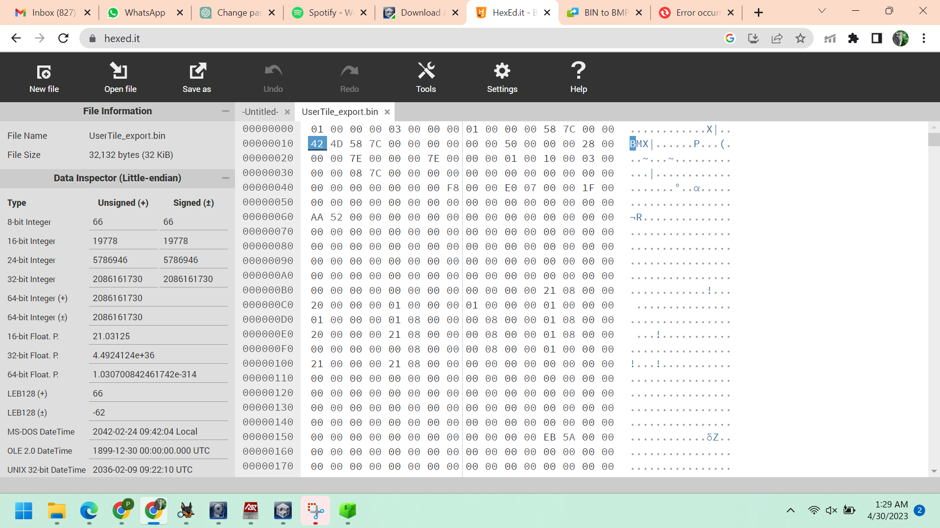

*Figure: Hex Value in hexed*



*Figure: User tile image*

**Conclusion:**

The examination of the individual's computer for forensic purposes has been completed. Relevant evidence, including data from pictures, emails, software usage, and connections to associated individuals related to the case, has been gathered and extracted as required. No further analysis is necessary at this time.